# CERTIFICATION

This is to certify that the long essay entitled: “**Analysis and Implementation of a Fake News Detection System For Landmark Metropolitan University Institute using Support Vector Machine (SVM)**” submitted to the department of Software Engineering,Faculty of Computer Engineering of Landmark Metropolitan University Institute, Buea in partial fulfillment of the requirements for the award of the Bachelors of Technology (B-TECH) Degree in Software Engineering is the original work of **NEBA NADINE MANKAA (LMU24SWE059)**conducted under supervision*.*

The thesis has been duly acknowledged and referenced.

Sign______________________________________ Date _______________________________

Mr KANG MODEST EKOME

**(Supervisor)**

Sign______________________________________ Date _______________________________

Mr KANG MODEST EKOME

**(Head of Department)**

# DECLARATION

I declare that this Long Essay has not been submitted, in whole or in part, anywhere in application for any diploma or degree.

Name………………………………………………………………………………………………..

Date ………………………………………………….Signature…………………………………...

# DEDICATION

I dedicate this work to my father, Neba Patrick Fochu whose unwavering support and love have been my guiding light.

# ACKNOWLEDGEMENTS

To my supervisor, Mr Kang Modest Ekome, your insightful guidance, patience, and unwavering support have been instrumental in the development and completion of this project. Your expertise and encouragement have pushed me to strive for excellence.

I am deeply grateful to my family, whose unwavering support and love have been my constant source of strength and inspiration. Your encouragement and faith in me have been invaluable throughout this journey.

I thank all my friends and those who supported me to realize this work, your encouragement, assistance, and belief in me have been deeply appreciated. This accomplishment would not have been possible without your collective support and motivation. Thank you all.

Lastly, I thank God Almighty for His blessings and guidance, providing me with the wisdom, patience, and perseverance to see this work through to completion.

# TABLE OF CONTENT

CERTIFICATION i

DECLARATION ii

DEDICATION iii

ACKNOWLEDGEMENTS iv

TABLE OF CONTENT v

LIST OF FIGURES viii

LIST OF ABBREVIATION ix

ABSTRACT x

CHAPTER ONE 1

GENERAL INTRODUCTION 1

1.1 INTRODUCTION 1

1.2 Background of Studies 1

1.3 Statement of the problem 2

1.4 Objectives of the study 3

1.4.1 General objectives 3

1.4.2 Specific Objectives 5

1.5 Significance of the study 6

1.5 Scope of the study 8

1.6 Definition of terms: 9

1.7 Organization of the study 11

CHAPTER TWO 13

LITERATURE REVIEW 13

2.1 Introduction 13

2.2 Review of Related Concepts and Conceptual Framework 13

2.2.1 Related Concepts 13

2.2.2 Review of Conceptual Framework 14

2.3 Review of Related Work 16

2.3.1 Fake news detection: a systematic literature review of machine learning algorithms and datasets 16

2.3.2 Fake News Detection Using Machine Learning 19

2.3.3 Automatic Detection of Fake News 21

2.3.4 Is it Fake? News Disinformation Detection on South African News Websites 24

2.4 Propose Solution 25

CHAPTER THREE 27

METHODOLY 27

3.1 Introduction 27

3.2 Research Methodology: A Descriptive Approach 27

3.3 Implementation of Fake News Detection System using Iterative Waterfall Model 28

3.3.1 Introductory 28

3.3.2 Phases of the Iterative Waterfall Model 28

3.4 Tools and Material use 29

3.4.1 Hardware Requirement 29

3.4.2 Software Requirement 30

3.5 System Modules 30

3.6 System Analysis 31

3.6.1 Functional Requirement 31

3.6.2 Non-functional Requirement 32

3.6.3 Cost Evaluation 33

3.6.4 Project Schedule 34

3.6.5 Use case Analysis 34

3.6.6 Sequence Diagram Sequence Diagram to check news 35

3.6.7 Activity Diagram 37

3.6.8 Class Diagram 38

3.6.9 Entity Relational Diagram 39

3.6.10 System Designs 40

CHAPTER FOUR 41

IMPLEMENTATION, RESULTS AND TESTING 41

4.1. Introduction 41

4.2. Implementation 41

4.2.1 Implementation of the AI Model Module: Data Collection, Preprocessing, and Detection 42

4.2.2 Implementation of user interface 47

4.3 Result of the Implementation 49

4.3.1 Onboarding UI on the browser 49

4.3.2 First Login UI on the browser 49

4.3.3 Second Login UI on the browser 50

4.3.2 OTP Verification UI on the browser 50

4.4. System Testing Strategies 51

4.4.1 Unit Testing 51

4.4.2 System Testing 52

4.4.3 Test cases for Functionality 52

CHAPTER FIVE 54

CONCLUSION AND RECOMMENDATIONS 54

5.1 Discussion 54

5.2 Conclusion 54

5.3 Recommendations 54

5.4 Perspective of Further Studies 55

*REFERENCING STYLE* 56

# LIST OF FIGURES

Figure 1: System architecture of FNDS 26

Figure 2: Project Gantt chart 34

Figure 3: Usecase Diagram of FNDS 35

Figure 4: Sequence diagram to check news 35

Figure 5: Sequence diagram to register user account 36

Figure 6: Activity Diagram of FNDS 37

Figure 7: class diagram for FNDS 38

Figure 8: Entity Relation Diagram for FNDS 39

Figure 9: System User interface designs 40

Figure 10: Code (import libraries) 42

Figure 11: Code (loading dataset) 42

Figure 12: Code (label and combine the dataset) 43

Figure 13: Code (adding processing functions and applying processing) 43

Figure 14: Code (Vectorize text data to TF-IDF) 44

Figure 15: Code (Split dataset) 44

Figure 16: Code (Train the SVM model) 45

Figure 17: Code (predict and evaluates) 45

Figure 18: Code (Collect and clean user input) 46

Figure 19: Code (Vectorize and Predict user input) 46

Figure 20: Code (interpreting predictions) 46

Figure 21: Code (testing user input prediction) 47

Figure 22: HTML of the App onboarding page 47

Figure 23: CSS of the onboarding page 48

Figure 24: Onboarding UI on the browser 49

Figure 25: First Login UI on the browser 49

Figure 26: Second Login UI on the browser 50

Figure 27: OTP Verification UI on the browser 50

Figure 28: Result of the model evaluation 51

# LIST OF ABBREVIATION

|  |  |
| --- | --- |
| **Abbreviation** | **Definition** |
| NLP | Natural Language Processing |
| FNDS | Fake News Detection System |
| SVM | Support Vector Machines |
| AI | Artificial Intelligence |
| ML | Machine Learning |
| UI | User Interface |
| URL | Uniform Resource Locator |
| SMS | Short Message Service |
| CNN | Convolutional Neural Network |
| DT | Decision Tree |

# ABSTRACT

In the age of information, the proliferation of fake news poses a significant threat to societal trust and informed decision-making. This project presents a comprehensive solution to this problem by developing a Fake News Detection System (FNDS) that leverages machine learning techniques to discern the legitimacy of news articles. The system is designed to be user-friendly, allowing users to input news text and receive immediate feedback on its authenticity.

The core of this system is based on a Support Vector Machine (SVM) model, chosen for its effectiveness in classification tasks. The implementation involves several crucial steps: data collection, preprocessing, feature extraction, model training, and validation. Two datasets, labeled as fake and true news, are utilized to train the SVM model. Preprocessing steps such as tokenization, stemming, and stop-word removal ensure the text data is clean and suitable for analysis. The Term Frequency-Inverse Document Frequency (TF-IDF) technique is employed to convert text data into numerical features that the SVM model can process.

The system is built with a user-centric approach, featuring a web interface that allows users to input any news text and instantly receive a prediction of its legitimacy. This interface is designed to be intuitive and responsive, ensuring accessibility across various devices. The project also emphasizes the importance of accuracy and efficiency, with extensive testing and validation processes in place to refine the model and minimize false predictions.

Overall, this Fake News Detection System serves as a valuable tool in the fight against misinformation in Landmark metropolitan university institute milieu. By combining advanced machine learning techniques with practical user interfaces, the system aims to empower users with reliable tools to verify news, thereby promoting informed and authentic information dissemination. This project underscores the potential of artificial intelligence in addressing contemporary challenges and enhancing digital literacy in an increasingly complex information landscape.

# 

# CHAPTER ONE

# GENERAL INTRODUCTION

## 1.1 INTRODUCTION

The fake news detection system for Landmark Metropolitan University Institute is aim to tackle the growing problem of false information in the digital sphere. It has grown more difficult to discern between reliable news sources and misleading content in a time when internet information intake is the norm. With the help of this project, educators, students, and the general public will be able to evaluate the reliability of news stories that are making the rounds on the internet.

Modern machine learning algorithms and natural language processing (NLP) methods are used by the Fake News Detection System, which provides a reliable way to identify if news stories that are circulating online are real or fake. Designed to satisfy the particular requirements of the academic community at Landmark Metropolitan University Institute, this system gives staff, instructors, and students the ability to critically assess news sources and discern between reliable and misleading material.  
This project's main goal is to provide Landmark Metropolitan University Institute with an extensive and user-friendly fake news detecting tool. Through the utilization of cutting-edge technology capabilities, such as real-time analysis and user-friendly interfaces, the system helps users make well-informed decisions and improves their media literacy.

This research is being carried out demonstrating a mutual dedication to advancing intellectual discernment and academic honesty with main aim to promote research on the identification of fake news and build a more knowledgeable and resilient online community.

## 1.2 Background of Studies

A thorough grasp of the difficulties presented by false information in an academic setting forms the basis of Landmark Metropolitan University Institute’s Fake News Detection System. The project acknowledges the negative consequences of disinformation on the integrity of intellectual debate and student learning, drawing on research in communication studies and media psychology. Research on cognitive biases and heuristics from psychology highlights how people, including teachers and students, are easily misled, emphasizing the value of focused interventions in learning environments. By utilizing advances in natural language processing and machine learning, the system aims to provide the university community with strong tools for evaluating news sources.

These research highlights the significance of developing students' information literacy and critical thinking abilities, which will equip them to distinguish reliable sources from misleading material. Research on the development of media literacy curricula offers useful insights into pedagogical approaches that work well for incorporating media literacy instruction into school curricula. These approaches also offer useful strategies for teaching students how to recognize bias in news reporting and assess the reliability of online sources.

Furthermore, studies on how students view fake news provide insight into their awareness of and vulnerability to false information, which helps to shape the development of focused interventions meant to improve students' media literacy and critical thinking skills. Through the integration of findings from these educational studies, the Fake News Detection System seeks to enhance current instructional endeavors at Landmark Metropolitan University Institute by furnishing instructors, staff, and students with an effective instrument for detecting and countering fake news in all the school communication channels. The initiative aims to strengthen the school community's resistance to false information and promote a culture of critical inquiry and responsible information consumption through multidisciplinary collaboration and a focus on media literacy education.

## 1.3 Statement of the problem

The spread of false information threatens the credibility of academic discourse and jeopardizes students' educational experiences, posing a serious threat to Landmark Metropolitan University Institute and other educational establishments across the globe. The quick spread of false material on digital platforms in recent years has sparked worries about how fake news may affect student learning results, academic integrity, and the legitimacy of educational institutions. Students are nevertheless prone to misinformation despite efforts to foster media literacy and critical thinking abilities, and they frequently lack the ability to discern between reliable sources and misleading content.

The ubiquity of false information in educational settings poses complex issues that require immediate attention and creative solutions. First and foremost, the dissemination of false material jeopardizes Landmark Metropolitan University Institute's educational purpose and damages the university's standing as a reliable source of information. Fake news also impairs students' capacity to interact critically with academic content, encouraging a climate of skepticism and uncertainty that impedes the search for the truth and intellectual development. Furthermore, the spread of erroneous material feeds misconceptions and lies, which prevents students from forming well-informed perspectives and prevents productive discussions within the academic community.

Proactive steps must be taken immediately to address the issue of fake news in the educational setting in light of these serious issues. The creation of a strong and efficient system for identifying fake news is essential to preserving the integrity of scholarly discourse and advancing media literacy among staff, faculty, and students. Through the use of cutting-edge technology and interdisciplinary knowledge, this project aims to equip the academic community with the skills and information required to successfully counteract the spread of false information. The project intends to develop a culture of critical inquiry and evidence-based thinking through focused interventions and instructional efforts, giving students the tools they need to properly navigate the digital information ecosystem. Finally, by tackling the underlying issues that lead to fake news and encouraging moral information practices, the Fake News Detection System has the ability to bolster Landmark Metropolitan University Institute's dedication to intellectual integrity and academic excellence in the digital age by encouraging ethical information practices.

## 1.4 Objectives of the study

### 1.4.1 General objectives

The Fake News Detection System project is a manifestation of the commitment in advancing information integrity and developing a responsible information consuming culture inside our institution. With this endeavor, we hope to create a powerful detection algorithm and an intuitive user interface that enable people to successfully counteract the spread of false information and confirm the legitimacy of news stories. The general objectives of this research are outline below

* **Create a Reliable Detection Model:** The goal is to create and apply strong machine learning algorithms and natural language processing (NLP) methods that can reliably identify between news stories that are real and those that aren't. This entails using a variety of datasets for model training, optimizing algorithms for maximum accuracy, and comparing the model's output to benchmark datasets to make sure it is dependable and useful in practical settings.
* **Encourage critical thinking and media literacy:** The goal is to improve the university community's media literacy and critical thinking skills by giving them the instruments and resources they need to distinguish reliable sources from misleading information.  
  This entails incorporating the system into media literacy initiatives.
* **Promote an Information Integrity Culture**: By educating people about the risks of false information and encouraging ethical information consumption, Landmark Metropolitan University Institute can foster a culture of intellectual integrity and responsible information consumption.
* **Promote an Information Integrity Culture:** the aim is educating people about the risks of false information and encouraging ethical information practices, Landmark Metropolitan University Institute can foster a culture of intellectual integrity and responsible information consumption.  
  Information campaigns, guest lectures, and seminars on the value of fact-checking information and the moral ramifications of disseminating unverified news are among the initiatives that will be undertaken.
* **Give Users real-time analysis to empower them:** The goal is to give people access to real-time news article detection and analysis so they can decide whether online information sources are reliable. The system will be able to provide users with instant feedback by processing and evaluating news items in real-time. By enabling users to swiftly confirm the veracity of news before sharing or acting upon it, this will aid in halting the spread of false information.
* **Contribute to Research in Fake News Detection:** Promote the field of fake news detection research by investigating novel strategies and tactics for locating and eradicating false material in educational environments. To add to the body of knowledge and guide future developments in false news detection systems, the initiative will involve continuing research and development, working with academic researchers, and publishing findings.
* **Collaborate with stakeholders:** Promote cooperation and joint ventures with academic staff, students, and other university stakeholders to guarantee that the project satisfies the requirements and anticipations of the campus community. Stakeholders will be consulted on a regular basis to obtain feedback, make sure the system is in line with learning objectives, and customize it to the unique requirements of the institute.
* **Boost Landmark Metropolitan University Institute Reputation:** By aggressively tackling the issue of false news and encouraging information integrity within the academic community, this will strengthen Landmark Metropolitan University Institute credibility and reputation as a reliable source of knowledge and expertise. The institution presents itself as a progressive establishment dedicated to maintaining societal trust and academic integrity by spearheading the fight against disinformation.

### 1.4.2 Specific Objectives

* Create and Apply Advanced Detection Algorithms: The system is aim to precisely identify false information, create and improve complex machine learning algorithms and natural language processing (NLP) methods. Use supervised learning strategies like neural networks, Decision Trees, and Support Vector Machines (SVM) in addition to unsupervised strategies like clustering. To ensure high precision and recall rates in the detection of false news.
* Provide a User-Friendly Web Application with an Intuitive User Interface to Help Users Easily Confirm the Authenticity of News Articles. Provide a user-friendly interface with straightforward text or URL input fields, real-time processing capabilities, and comprehensible, informative output. Results like confidence scores, source reliability ratings, and justifications for the credibility evaluation should be shown on the interface. Additionally, it will include accessible design principles to meet the demands of a variety of users.
* To safeguard user data, make sure the Fake News Detection System complies with strict security and privacy guidelines. The use of privacy-preserving methods, secure data storage options, and strong encryption. Maintain adherence to pertinent data protection laws, update methods to handle new risks, and carry out routine security audits.
* Track and Assess System Efficiency: Constantly track the system's performance and get input from users to make it more precise and efficient. Use analytics software to monitor important performance indicators including user engagement, false positives/negatives, and accuracy rates. Utilize user reports and surveys to gather input, which can then be used to improve system operation, update datasets, and improve algorithms.
* Implement Alert Systems in Real-Time: Create an alert system that alerts people in real time when potentially fraudulent news is discovered. In order to facilitate prompt awareness and action, develop a system that notifies or alerts users to newly discovered disinformation or trending false news items.
* Provide Detailed Assessment Measures: Establish comprehensive assessment metrics to evaluate the effectiveness and impact of the system for detecting fake news. Set up measures for things like user engagement, reaction time, detection accuracy, and educational impact. Make data-driven improvements by using these measures to carry out frequent performance evaluations.
* Establish a Reporting and Feedback Mechanism: Provide a thorough feedback and reporting system so that users may point out errors and make suggestions for improvement. Provide a user-friendly reporting function for the system that lets users report recommendations and flag false positives or negatives. Make ongoing adjustments to the user interface and detection algorithms based on this feedback.
* Adaptive learning strategies should be used. Enhance the system's capacity to identify and react to new forms of false information by implementing adaptive learning. Include machine learning models in the system so that it can adjust to new patterns and trends in disinformation. This will help the system stay effective.
* Incorporate routes of communication for observation: Include tools for tracking communication channels so that the system may identify and examine the spread of false information through school channels. Provide algorithms to scan and evaluate content shared across the school communication channels, pointing out patterns and false information sources.

## 1.5 Significance of the study

The development and implementation of a Fake News Detection System for Landmark Metropolitan University Institute are of great importance in a number of angles. With regard to the intellectual, social, and technological spheres, this project makes several significant contributions and tackles important concerns brought about by the spread of fake news.

* Improving Critical Thinking and Media Literacy: Improving media literacy and critical thinking among Landmark Metropolitan University Institute’s teachers, staff, and students is one of the project's main goals. Those who live in a time where false information spreads quickly via digital channels must be able to critically assess the reliability of news sources and the information they take in. This project helps educational activities focused at encouraging critical analysis and informed decision-making by offering a trustworthy tool for identifying bogus news.
* Encouraging Research Quality and Academic Integrity: The quality and integrity of information are essential to the academic environment. The Fake News Detection System makes sure that researchers and students use reliable and authentic sources for their work, protecting academic integrity.
* Advancing Knowledge-Based Decision-Making: Apart from imparting knowledge, the system facilitates well-informed decision-making throughout the university. When administrators, teachers, and students have access to accurate and trustworthy information, they can make better judgments. Because the effects of false information can be extensive, this is especially crucial for university policies, research funding, public relations, and community participation.
* Contributing To Technological Advancement: The initiative advances the fields of artificial intelligence (AI) and natural language processing (NLP) technologically. The research pushes the boundaries of artificial intelligence and natural language processing by creating and optimizing machine learning algorithms for the detection of fake news. Fake news detection technologies can be further improved and innovated upon by sharing the insights and methods gained from this study with the larger scientific community.
* Addressing a Societal Challenge

The problem of fake news is not limited to academia; it is a major social issue that has an impact on social harmony, public health, and democracy. The creation of a reliable mechanism to identify and counteract false information fills a vital void in society. It makes people more capable of navigating the information world and makes communities more resilient and knowledgeable.

* Increasing Trust and Reputation: The deployment of a state-of-the-art Fake News Detection system further solidifies Landmark Metropolitan University Institute's standing as a progressive organization dedicated to tackling modern issues. It shows the institution’s commitment to using technology to improve both its local community and society as a whole.

In conclusion, there are several reasons why the Fake News Detection System project at Landmark Metropolitan University Institute is important. It addresses a critical societal issue and advances technology while improving media literacy, academic integrity, and informed decision-making.

## 1.5 Scope of the study

In order to successfully build, deploy, and evaluate the system at Landmark Metropolitan University, the Fake News Detection System project must cover a number of important areas. Clarifying what will and won't be addressed, this scope establishes the project's parameters and these are outline below

* Technological Development: Detection Algorithms: In order to reliably identify false news, the study will concentrate on the creation and application of sophisticated machine learning algorithms and natural language processing (NLP) methods.  
  User Interface: The project will involve creating an intuitive web application that will let users enter news articles and get authenticity ratings.  
  Real-Time Processing: The system will have the ability to analyze and comment in real-time on the veracity of news reports.
* Information Gathering and Administration: Training and verifying the detection algorithms in the study will entail gathering and organizing enormous datasets that include both real and fraudulent news stories. Reliable datasets for model training will be ensured by the implementation of procedures for precise data labeling.
* Evaluation of Performance: Using metrics, the study will assess the efficacy and accuracy of the detection algorithms.
* Privacy and Security: The project will make sure that the system complies with strict security and privacy guidelines, safeguarding user information and upholding confidence. The system will abide with university policy and applicable data protection laws.
* Architecture of the System: Establish a solid backend architecture to facilitate the processing, storing, and retrieval of data.
* Real-Time alarm System: Create a real-time alarm system that, as soon as it detects possible bogus news, it warns users. Use in-app alerts and push notifications as notification channels to keep users informed.
* Integrate the alarm system with the school's communication channels to track and examine the dissemination of false information. Provide users with real-time knowledge regarding misinformation by automatically generating notifications when possible fake news trends are identified on the school communication channel.
* Constant Enhancement: Procedures and measures will be put in place for ongoing observation and assessment of the system's functionality, making sure that the system is updated and maintained on a regular basis to take into account technical improvements based on user feedbacks.
* Research and Publication: Through the documentation of techniques, results, and best practices in the creation of false news detection systems, the study will support academic research.
* **Limitations**Exclusions from the Scope: The project will not go beyond creating detection algorithms for textual news articles to include other forms of misinformation like deepfakes. Geographic Focus: While larger community involvement will be taken into consideration, the university community (Landmark Metropolitan University Institute) will be the main focus.

## 1.6 Definition of terms:

* Fake news: these are intentionally misleading or inaccurate information that is disseminated to trick people. False stories, hoaxes, propaganda, and misinformation are a few examples of fake news.
* Machine learning (ML): A branch of artificial intelligence (AI) called machine learning (ML) focuses on teaching algorithms to identify patterns in data and make judgments. By examining huge datasets of news stories, machine learning (ML) is utilized to create models that can automatically identify false information.
* Natural Language Processing (NLP): The study of how computers and human language interact. Computers can now comprehend, interpret, and produce human language thanks to NLP approaches. NLP is being utilized in this project to analyze news article text in order to identify false information.
* Detection Algorithm: A method that the system uses computationally to detect false news. Detection algorithms assess articles as authentic or fraudulent by analyzing news content, extracting features, and using machine learning and natural language processing techniques.
* Feature Engineering: These are the procedure for choosing, adjusting, and producing variables (features) to enhance machine learning models' functionality. Features for detecting fake news could include publishing history, source reliability, and linguistic patterns.
* Real-Time Processing: This feature guarantees prompt identification and notification of false news by enabling the system to evaluate and offer commentary on news articles as soon as they are uploaded by users.
* User Interface (UI): The area of the system that users directly interact with. Users can input news articles and get trustworthiness assessments on the web applications thanks to an intuitive user interface.
* Dataset: A set of information used to test and train machine learning models. Real and fraudulent news pieces collected from multiple sources are included in the datasets for this project.
* Data labeling: This is the process of giving labels to individual data points. In the context of this research, it entails classifying news items as authentic or fraudulent in order to provide a labeled dataset that will be used to train the detection algorithms.
* Data protection: This refers to the steps taken to prevent unauthorized use, access, disclosure, disruption, alteration, or destruction of sensitive and identifiable data. Retaining user confidence and adhering to rules depend on data privacy.
* Alerts Notification System: This is a system function that alerts people in real time when potentially fraudulent news is discovered. Email, SMS, push notifications, and in-app alerts are just a few of the ways via which notifications can be sent.
* Accuracy Metrics: These are quantitative measurements that assess how well detection algorithm’s function. Recall, and precision are examples of common metrics.  
  Precision: The proportion of actual positive outcomes to all positive outcomes that the model correctly anticipated. It gauges how accurate the optimistic forecasts were.  
  Recall: The proportion of actual positive results to true positive results. It gauges how well the model can locate all pertinent examples.

## 1.7 Organization of the study

This study, which aims to build and deploy a Fake News Detection System for Landmark Metropolitan University Institute, is organized in a way that facilitates an in-depth examination of the research process, techniques, outcomes, and consequences in a straightforward and methodical manner. Every chapter is structured to tackle distinct facets of the project, guaranteeing a coherent progression and all-encompassing discussion of the subject.

* **Chapter One: Introduction**

This chapter introduces the study's context by giving a thorough overview of the problem of fake news and how it affects both society and educational settings. The problem statement, study objectives, research questions, significance, and scope are outlined. By directing readers through the study's main emphasis and anticipated contributions, this foundational chapter seeks to explain the purpose and significance of the research.

* **Chapter Two: Literature Review**

The literature review provides a thorough analysis of previous studies on the topic of fake news, how to spot it, and the theoretical frameworks that guide the investigation. In this chapter, prior research is critically analyzed, research gaps are noted, and the current effort is placed within the larger academic discourse. It offers a strong empirical and theoretical basis for the creation of the false news detecting system.

* **Chapter Three: Methodology**

This chapter describes the process used to create the Fake News Detection System. Using datasets of real and fake news stories, the research strategy takes a quantitative approach. After substantial preprocessing using NLP techniques like tokenization and feature extraction, data collecting entails sourcing from public repositories and web scraping. Development environments like Jupyter Notebooks are used in conjunction with tools like, Scikit-learn, Python. The core modules of the system include alarm notification, machine learning, feature extraction, data ingestion, and user interface. A thorough specification of the system requirements is produced after system analysis determines the needs and difficulties of the stakeholders. A clear and structured development process is ensured by design diagrams, which include use case, class, sequence, data flow, and system architecture diagrams. These diagrams offer visual blueprints for execution. This methodology guarantees a methodical approach to developing a user-friendly and successful fake news detecting system.

* **Chapter Four: Implementation and Result**

The results of the system's testing and deployment for identifying false news are presented in this chapter. The results of usability testing the user interfaces, comprehensive performance metrics of the detection algorithms, and the system's influence on users' media literacy are all included. To demonstrate the efficiency of the approach, the outcomes are bolstered by numerical data and visual aids.

* **Chapter Five: Discussion and Conclusion**

The results of the Fake News Detection System project are interpreted in this chapter, emphasizing the system's accuracy and intuitive interface. The method greatly improves media literacy, academic integrity, and well-informed decision-making. Notwithstanding difficulties with data quality and processing requirements, the system's efficacy in promptly identifying and warning users about false information is apparent. To remain relevant, the project suggests regular updates and improvements. All things considered; the system is an essential weapon in the fight against false information

* **References**An exhaustive list of all the sources that were cited during the research, prepared in compliance with standard citation requirements to guarantee academic integrity and reliability.
* **Appendices**The appendices contain additional materials that complement the research, giving the study more context and depth.

# CHAPTER TWO

# LITERATURE REVIEW

## 2.1 Introduction

In the digital age, false news has become a ubiquitous problem that affects public trust, politics, education, and other facets of society. The phrase "fake news" refers to a variety of inaccurate information, including headline tricks, entirely made-up articles, and media manipulation. People now find it more challenging to distinguish between falsehoods and reliable information due to the quick spread of such content on social media and other internet platforms. The goal of this chapter is to present a thorough analysis of the body of research on fake news and how to spot it, setting the stage for the creation of a functional fake news detection system for Landmark Metropolitan University Institute

Subsequently, the chapter looks at the current tools and techniques for identifying false news. They include deep learning and sophisticated natural language processing (NLP) techniques, as well as more conventional machine learning techniques. In order to improve the efficacy and precision of fake news detection systems, this review analyzes the advantages and disadvantages of these approaches in order to pinpoint the most promising approaches.

The literature study concludes by summarizing the state of the art in the field of false news detection, emphasizing important discoveries and suggesting areas for further research. This chapter provides an in-depth analysis of current research and approaches, laying the groundwork for the later creation and deployment of a Fake News Detection System customized to Landmark Metropolitan University Institute requirements. The knowledge gathered from this review will guide the system's design and operation, guaranteeing that it tackles the particular issues raised in the literature and successfully advances academic integrity and media literacy among university students.

## 2.2 Review of Related Concepts and Conceptual Framework

### 2.2.1 Related Concepts

* Fake news: Misinformation or fraudulent information presented as news is referred to as fake news. This can involve entirely made-up narratives, photoshopped imagery, deceptive headlines, or overstated assertions. Fake news frequently aims to mislead, sway public opinion, or create sensationalism in order to increase clickthrough rates and ad income. Social media networks let fake news spread swiftly because they allow it to reach a big audience quickly and with little verification.
* Disinformation vs. Misinformation: Disinformation is deliberately misleading content meant to deceive or exert influence. It is frequently driven by politics and is purposefully misleading. Contrarily, misinformation is defined as false information disseminated without malicious intent. Usually, ignorance or misinterpretation rather than a conscious attempt at deception is the cause.
* Media Literacy: Media literacy refers to the capacity to obtain, examine, assess, and produce media in a variety of formats. Critical thinking abilities are included, which are important to comprehend how the media functions in society and to assess the reliability of information sources. Improving people's media literacy is essential in the battle against false information since it enables them to choose the information they take in with knowledge.
* Natural Language Processing (NLP): Natural Language Processing (NLP) is an artificial intelligence field that studies how computers and human language interact. It involves analyzing and synthesizing natural language and speech using computational approaches. NLP approaches are used to process and comprehend news article text in order to find patterns and traits that are suggestive of fraudulent information. This process is known as fake news identification.
* Machine Learning: The creation of algorithms that can learn from and make predictions based on data is known as machine learning, and it is a subset of artificial intelligence. In the field of fake news identification, machine learning models are trained on datasets containing labeled news articles (false and genuine) in order to categorize new articles as either fake or real. Methods including deep learning, supervised learning, and unsupervised learning are frequently employed.

### 2.2.2 Review of Conceptual Framework

The creation and implementation of the Fake News Detection System are guided by a number of important theories and models that are integrated into the system's conceptual framework. Understanding how fake news travels and how to successfully detect and combat it is made possible thanks to this methodology.

* **Information Theory in Fake News Detection**

Information theory helps detect fake news by measuring the content and patterns in news articles. Real news is usually well-organized with lower entropy, while fake news is more chaotic with higher entropy. Algorithms can spot fake news by looking at these differences. Information theory also helps remove "noise" or misleading information and ensures that communication channels transmit accurate data. It uses techniques to identify and correct errors in news reports. In machine learning, information theory improves the detection of fake news by extracting important features, optimizing model training, and evaluating performance. This integration enhances the accuracy and reliability of identifying false information.

* **Cognitive Bias Theory in the Context of Fake News Detection**Cognitive biases are mental shortcuts that streamline information processing but often lead to errors in judgment, making people more susceptible to fake news. Key biases include confirmation bias, where people favor information that supports their beliefs; the illusory truth effect, where repeated false statements seem true; anchoring bias, where initial information overly influences decisions; the availability heuristic, where easily accessible information is overvalued; the bandwagon effect, where popular beliefs are adopted; and the backfire effect, where contradicting facts reinforce false beliefs. Understanding these biases helps in creating effective fake news detection systems and promotes critical thinking.
* **Theories of AI and Machine Learning**

The development of algorithms for the detection of fake news is guided by theories related to machine learning. Particularly pertinent is supervised learning, in which models are trained on labeled datasets. Regression analysis, classification, and clustering are some of the techniques used to create models that forecast the probability that an item is fraudulent. The fundamental ideas and techniques for creating systems that can learn from data and make wise judgments are provided by the theories of artificial intelligence (AI) and machine learning. These ideas pave the way for the development of highly intelligent algorithms for the identification of fake news, which are capable of pattern recognition, extensive data analysis, and precise prediction. Artificial intelligence (AI) and machine learning provide effective tools to counter the spread of false information and improve the integrity of data in the digital age. These technologies combine supervised, unsupervised, and deep learning approaches with an awareness of cognitive biases and learning process optimization.

## 2.3 Review of Related Work

### 2.3.1 Fake news detection: a systematic literature review of machine learning algorithms and datasets

Contributors: Humberto Fernandes Villela (Universidade FUMEC), Fábio Corrêa, FUMEC University, Judgema Nery Ribeiro, Suely de Araújo (Universidade FUMEC), Air Rabelo(FUMEC University), At the Federal University of São João del Rei, Dairinton Barbosa FeresCarvalho   
This research, which is broken up into sections on the introduction and fake news detection, is an in-depth assessment of the importance of fake news and the developments in its identification.  
The Introduction emphasizes how urgent it is to combat fake news because it has the power to have a big impact on politics, the economy, and society. Fake news has a significant influence on public opinion and election results; notable examples include the US presidential election in 2016 and the Brazilian elections in 2018. Researchers are concentrating on creating algorithms for the automatic detection of fake news because of its significant social impact. The accuracy of these algorithms (that is, the percentage of correctly classified news items) is the main metric used to assess their efficacy. The introduction highlights the need for more study to increase the robustness and generalizability of these algorithms, especially with diverse datasets and languages. The Research addresses the need to be educated in a digitally linked world in the part on spotting fake news. The propagation of fake news is aided by the abundance of communication data that has been generated by the Internet of Things (IoT) and other digital channels. This data can be converted into insightful knowledge. The term "fake news" refers to deliberate misinformation that aims to mislead and frequently causes uncertainty and confusion. The essay demonstrates the range of shapes that fake news may take, such as satire, clickbait, propaganda, and hoaxes, all of which make it harder to identify because of the subtle differences in human language and intent. It is especially highlighted how social media plays a part in the propagation of fake news, as these platforms make it possible for sensational and frequently inaccurate information to spread quickly. The difficulties in spotting false news are addressed, including similarities to material that seems believable and the absence of disclaimers. A number of techniques for identifying false information, such as textual analysis, are examined; nevertheless, their limits are noted because of the intricacy of language and the skill of those who fabricate false information. In order to increase detection accuracy, the book also emphasizes how crucial it is to comprehend the background information and intent of news stories.

**Methodology**

This study's methodology is exploratory in nature, and it employs a qualitative analysis approach to examine the accuracy of the algorithms used to identify fake news. The study process is founded on an organized review of scientific literature about machine learning techniques and datasets.  
**Technology Used**

* The study used a variety of methods, which are outlined in Figure 1, to identify bogus news. These include the application of machine learning, natural language processing, and artificial intelligence (AI) algorithms.
* A thorough analysis is conducted on the datasets and algorithms utilized in the fake news detection process. In comparison to other statistical modeling and learning techniques, deep learning offers a significant advantage in resource maps and self-learning, as demonstrated by the study conducted by Ahmedali et al. (2020).
* The study offers a table that lists the accuracy of several neural network models and machine learning algorithms that have been applied to the detection of fake news. The table presents the accuracy scores obtained from multiple research papers for various algorithms, including Convolutional Neural Network (CNN), Naive Bayes, Random Forest, and others.

**Strength of this Study**

* The study uses a methodical approach to literature evaluation, which enables a thorough examination of the many computational methods, algorithms, and datasets utilized in the detection of fake news.
* The paper offers a comprehensive review of the state-of-the-art in the field by covering a wide range of machine learning and natural language processing techniques that have been developed for spotting false news.
* The investigation looks at the algorithms' accuracy, which is an important parameter to assess how well false news detection systems work and how applicable they are in real-world scenarios.
* The study emphasizes the shortcomings of existing methods, recognizing that even the most effective algorithms can only identify false news with an accuracy of only 54% when compared to human judgment.

**Limitations of this Study**

* The study mainly focuses on text-based fake news identification, with little investigation into multimodal strategies that can improve detection performance by utilizing audio, visual, or other data sources.
* The study lacks comprehensive details regarding the computational complexity, training needs, and practical deployment difficulties of the various algorithms, aspects that are crucial for successful application.
* The research included in the study is restricted to the time period covered by the systematic literature review, which may not encompass the most recent developments in the field.
* The study skips over important issues that should be taken into account for the appropriate creation and use of automated false news detection systems: the social, ethical, and privacy ramifications of doing so.

**Recommendation for future works**

* Extend the study to examine multimodal methods that integrate textual, visual, and additional data sources in order to create more thorough and precise false news detection systems.
* Perform thorough analyses of the algorithms' scalability, computing efficiency, and viability in real-world scenarios, taking into account any deployment difficulties.
* Examine how automated false news detection affects society, ethics, and privacy. Create best practices and standards for the responsible design and implementation of these systems.
* Since the world of fake news and the computational methods used to combat it are always changing, keep the research up to date by including the most recent developments in the field.

### 2.3.2 Fake News Detection Using Machine Learning

Contributors: Mrs. Usha M1, Lakshmi, Divyashree and Deenakumari

The introduction draws attention to the increasing occurrence of "Fake News" content, especially in the context of the COVID-19 epidemic, which has facilitated the dissemination of false information, conspiracies, and deceptive statements. The public's bewilderment, fear, and suspicion have been stoked by these harmful health recommendations, which have exposed many people to illnesses more serious than the virus itself. Data from several social media sites, such as Facebook, indicates that around 50 million false and misleading posts on COVID-19 were taken down in April 2020. Over 1,500,000 people were also questioned by Twitter for spreading false information and participating in what they called "manipulative behavior" during that same period.

**Methodologies use:**

* **Unique character attributes**: Mini-character strings, one-hot vectors, and input vectors with a range of properties were employed in the study to represent the prior character and forecast the next. This makes it possible for the algorithm to provide these earlier characters with the whole training phase.
* **Sentiment analysis capabilities:** Prior to using the sentiment analysis features, the study classified the text or sentences in the model as having a positive, negative, neutral, or complicated sentiment.
* **Features of language:** As part of the classification process, an item of fake news is given a category. Any other language can be translated into text to do this. The attribute names are arranged based on the sorts of data they include

**Technologies Employed**

The study made use of cutting-edge machine learning methods, like the Ada-boost classifier.

* When it came to F1-Measure, recall, accuracy, and precision, the Ada-boost classifier outperformed other machine learning methods including the Decision Tree (DT) and k-Nearest Neighbor.
* Ada-boost produced the highest comparable results, with 81.82% F1-Measure, 86.36% recall, and 76.76% precision.
* A 12-core i7 processor running at 2.7 GHz with 8 GB of RAM and Google Colab are used for the experiments.

All in all, the study made use of Google Colab's computational capabilities to identify and categorize bogus news by combining natural language processing methods, sentiment analysis, and machine learning algorithms like Ada-boost.

**Strength**

* **Extensive Methodology:** To address the problem of fake news detection, the study used a multifaceted methodology that included unique character traits, sentiment analysis capabilities, and linguistic characteristics.
* **Advanced Machine Learning Models:** The study made use of cutting-edge machine learning methods, like the Ada-boost classifier, which outperformed other algorithms like Decision Tree and k-Nearest Neighbor in terms of performance.
* **Thorough Testing and assessment:** In order to determine the efficacy of their strategy, the researchers carried out extensive testing and assessment, providing metrics including F1-Measure, recall, accuracy, and precision.

**Limitations**

* Data Restrictions: The study used a small dataset, consisting of only about 1,100 news articles, which might not be enough to fully represent the variety and breadth of fake news that exists in the actual world.
* Limited Scope: The study did not investigate the detection of multimedia-based fake content, such as altered photographs or videos, and instead concentrated on text-based fake news.
* Computational Resources: The study was restricted to using Google Colab's computer resources, which might not be indicative of deployment conditions in the real world where the model would have to handle more complex data and higher processing demands.

**Recommendations for future works**

* Extend Dataset: To more accurately reflect the changing environment of fake news across many platforms and domains, expand the dataset's size and diversity.
* Incorporate Multimodal Techniques: Examine how text, picture, and video analysis methods can be used to create a more complete false news detection system that can manage the variety of online information.
* Real-world Deployment and Evaluation: Evaluate the model's performance in real-world deployment settings, considering user-friendliness, computational efficiency, and scalability.
* Collaborative Efforts: To further improve and strengthen the false news detection skills, it is recommended that researchers, fact-checkers, and domain specialists collaborate in an interdisciplinary manner.

2.3.3 Automatic Detection of Fake News   
**Contributors:**  
Verónica Rosas Pérez from the University of Michigan, Bennett Kleinberg from the University of Amsterdam, Lefèvre Alexandra, Mihalcea Rada from the University of Michigan

Given the increased spread of false information online, especially through social media, news blogs, and online newspapers, the study introduction addresses the significance of detecting fake news. It is critical to detect fake content in online sources, especially since 62% of American adults get their news from social media. A recent study by Jumpshot Tech Blog shows that Facebook referrals contribute significantly to traffic to fake news sites, with 50% of all traffic going to these sites and 20% going to reputable websites.

The study further highlighted that traditional computer techniques for identifying false information have depended on resources such as satirical news sites (like "The Onion"), websites that track viral news (like BuzzFeed), and fact-checking sites (like "PolitiFact" and "Snopes"). These sources do, however, come with a few drawbacks. For example, satirical content might complicate the analysis by introducing aspects that can be confusing, such comedy and absurdity. Fact-checking websites are generally limited to particular fields, such as politics, and their reliance on human verification of assertions makes cross-domain generalization challenging.

The research suggests creating new models and computing resources for false news detection in order to overcome these issues. It presents two new datasets that span seven distinct domains. While one dataset is taken directly from the web, the other is gathered using a combination of manual and crowdsourcing annotation procedures. The study does exploratory analyses using these datasets to find linguistic features that are frequently present in fake news material. The researchers then use these language traits to construct false news detectors, which they have found to have up to 76% accuracy rates. To put the results in context, the performance of these classifiers is tested against a human baseline.

**Methodologies  
Gathering Datasets:**

* Crowdsourcing Fake News Dataset: Using a focus on six news areas (business, education, etc.), the study uses crowdsourcing to gather a new dataset. This approach makes use of the many contributions from many sources to create a solid dataset.
* Acquiring Reputable News: A dataset containing reliable news is gathered from six categories: sports, business, entertainment, politics, technology, and education. Reputable media sites like ABC News, CNN, and Fox News are examples of news sources. Cross-referencing many sources is one way that this method ensures the credibility of the news.

**Platform for crowdsourcing:**

* The crowdsourcing is carried out via Amazon Mechanical Turk (AMT), which offers a platform for effectively gathering data from a variety of contributors.

**Technology Used**

* Tools for Crowdsourcing: AMT, or Amazon Mechanical Turk, is used to collect a variety of news data and guarantee a broad coverage of news areas.
* Analytical Statistics: To distinguish between authentic and fraudulent news stories, word and sentence statistics are examined.

**Strength of the Study**

* Various Dataset: A variety of domains, including sports, business, entertainment, politics, technology, and education, are included to improve the dataset's overall comprehensiveness and cross-platform applicability.
* Reliable sources: Reputable news sources are the source of legitimate news data, guaranteeing high-caliber input for the dataset.
* Method of Crowdsourcing: Wide-ranging data collecting is made possible by using AMT, which leverages the contributions of multiple sources to provide comprehensive and diverse data.

**Limitations of the study**

* Domain Limitation: Although the dataset spans several domains, the fake news dataset places a lot of emphasis on particular kinds of false news, which may restrict how broadly the model can be applied to other kinds of fake news that aren't covered by the dataset.
* Utilizing Crowdsourcing: There may be discrepancies in the caliber of crowdsourced data as well as in the way contributors assess news stories.
* Label Accuracy: The method of classifying news as authentic or fraudulent can be arbitrary, and incorrect labeling can compromise the overall validity of the information.

**Recommendations for further work**

* Extend Domains: To improve the model's resilience and cover a wider range of news categories, future work should incorporate other domains.
* Improve the Labeling Procedure: Increase the level of validation procedures for crowdsourced labels in order to guarantee the dataset's increased accuracy and dependability.
* Include Cutting-Edge Technologies: Make better use of natural language processing and sophisticated machine learning methods to raise the precision of false news identification algorithms.
* Multilingual Datasets: To make sure that fake news detection systems can function properly in various linguistic situations, develop datasets in many languages.
* Long-Term Research: To better understand how the characteristics of fake news change over time, conduct longitudinal studies and update detection models accordingly.
* Analysis of User Behavior: To further improve the identification algorithms, incorporate evaluations of user behavior and engagement patterns with news articles.

2.3.4 Is it Fake? News Disinformation Detection on South African News Websites  
The contributors are:  
Harm de Wet from the University of Pretoria's Department of Computer Science, South Africa.  
Vukosi Marivate from the University of Pretoria's Department of Computer Science in South Africa.

According to this study, fake news has grown to be a serious problem because of how quickly it spreads via social media and other online channels, affecting people's attitudes and actions. According to a study, 20% of all traffic to fake news websites came from Facebook referrals, which means that efficient techniques for detecting fake news are imperative. Conventional methods, which focus on particular subjects and require expert verification, have drawbacks. They rely on datasets from satire sources and fact-checking websites. In an effort to enhance the identification of fake news, this study presents two new datasets that span several areas and were gathered using both manual and crowdsourcing techniques.

**Technologies Employed:**

* The study used deep learning methods—more especially, LSTM models—to identify false information.
* A collection of news stories from South African news websites was used to train and assess the models.

**Strength of the study:**

* The study examined deep learning-based and frequency-based methods for detecting fake news, offering a more thorough examination.
* It was possible to identify intricate language characteristics that might be signs of bogus news by using LSTM models.
* The assessment on a news dataset from South Africa enriches the body of knowledge on fake news detection.

**Limitations:**

* Due to its exclusive focus on South African news websites, the dataset's size and coverage may be restricted. The results may be more broadly applicable if they were expanded to include a wider range of news sources.
* The lack of information in the study regarding the model architecture and feature engineering made it challenging to evaluate the in-depth technical elements.

**Recommendations for Further Research:**

* To increase the dataset's diversity and representativeness, enlarge it to include news sources from additional nations or regions.
* Give more thorough explanations of the LSTM model architectures that were employed and the feature engineering procedure.
* To have a better understanding of the relative advantages and disadvantages of the suggested models, compare their performance to that of other cutting-edge techniques for detecting fake news.

## **2.4 Propose Solution**

This project suggests creating a simple Fake News Detection System (FNDS) that makes use of fundamental machine learning and natural language processing (NLP) methods in order to tackle the urgent problem of fake news propagation in the setting of a school. A single language is supported and text-based information is the only focus of the system's straightforward, user-friendly design, which is in line with the requirements and resources of an educational environment. A carefully selected dataset of authentic and fraudulent news items that are pertinent to the academic community will be used by the FNDS. Volunteers will personally annotate this dataset after it has been gathered from reputable news sources, guaranteeing that it contains representative and varied information.  
Fundamental machine learning techniques that are well-known for their effectiveness and simplicity of use, like Logistic Regression and Naive Bayes, will be used by the system. The dataset will be used to train these models to recognize important linguistic cues that are suggestive of false news, like sensationalist language, a dearth of reliable sources, and narrative flaws. The text data will be preprocessed using fundamental NLP techniques including tokenization, stop-word removal, and stemming in order to prepare it for analysis by the AI models.  
The system will include a straightforward web-based interface where users can enter text for analysis, ensuring that it is usable and accessible for usage in schools. Next, the system will give a concise explanation of its decision based on the identified linguistic features, coupled with a clear, binary output indicating whether the news item is likely to be phony or authentic. This openness builds trust and adds educational value by assisting users in understanding the reasoning behind the classification.

**System Architecture of Propose System Solution**

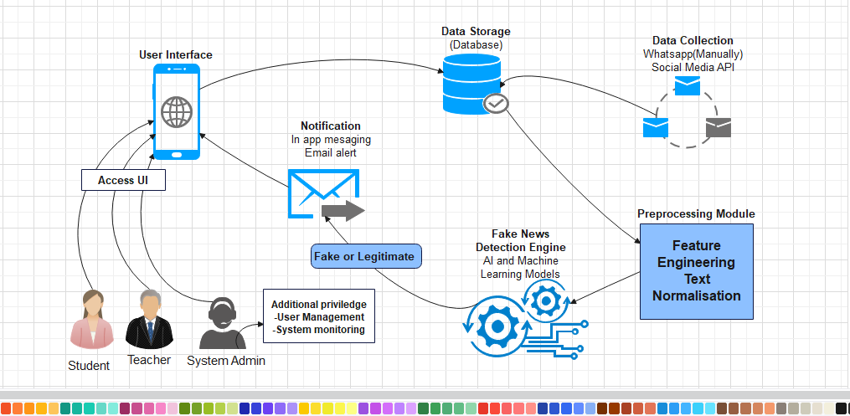

#### Figure 1: System architecture of FNDS. Source: EDrawmax

# CHAPTER THREE

# METHODOLY

## 3.1 Introduction

The approaches and resources used in the creation and execution of the fake news detection system customized for Landmark Metropolitan University will be discussed in this chapter. The whole process used to create, develop, and deploy the fake news detection system is described in this chapter. A strong, accurate, and user-friendly system that meets the unique needs of the Landmark Metropolitan University community is ensured through the integration of many approaches and resources. A comprehensive plan for the project's effective completion is provided by the thorough analysis of the materials and procedures.

3.2 Research Methodology: A Descriptive Approach  
3.2.1 Introduction

This section outlines the descriptive research methodology used to develop a fake news detection system for Landmark Metropolitan University. It emphasizes accurate data collection, detailed analysis, and user-centric system development. The phases implemented are;

* **Data Collection**: With an emphasis on communications pertaining to universities, data is obtained via Facebook, WhatsApp, YouTube, Instagram, and Twitter.
* **Techniques:** Make use of social media APIs to gather data in an organized manner, use web scraping in situations where APIs are not enough, Gather information by hand from university social media accounts and WhatsApp groups.
* **Data Annotation**: Manually annotate data by asking volunteers, instructors, and students to classify it as "real" or "fake" according to certain rules that will guarantee accuracy and consistency.
* **Feature Extraction**: Text processing by tokenizing text to words or sentences using tokens. Replace all punctuation, convert to lowercase, and apply stemming or lemmatization to normalize the text, transform text into numerical features by using TF-IDF vectorization.
* **Algorithm Selection for Model Development:** To maximize text categorization performance, Support Vector Machine (SVM) with a linear kernel is use.
* **Training and Tuning:** Train the SVM model on the TF-IDF-transformed data, optimize hyperparameters to improve performance.
* **Model Evaluation:** Performance Metrics: Evaluate the model using accuracy, precision, recall, and F1-score to measure its ability to detect fake news.
* **Backend Development:** Use Python and Flask for data processing, model inference, and API integration.
* **Database management**: Use MySQL for relational data storage.
* **User Interface Frontend Development:** Make use of HTML, CSS, and JavaScript to create an accessible and user-friendly interface.
* **Validation and Testing**: User Acceptance Testing of the system with teachers and students, gathering feedback via interviews and questionnaires to make it better. Iterative updates and enhancements can be made by incorporating user feedback for continuous improvement.

## **3.3 Implementation of Fake News Detection System using Iterative Waterfall Model**

3.3.1 Introductory

The Iterative Waterfall Model is a systematic software development strategy that permits revisiting and improving earlier phases in response to feedback and assessment. This approach ensures a flexible yet systematic process in the development of a fake news detection system for Landmark Metropolitan University.

### **3.3.2 Phases of the Iterative Waterfall Model**

* **Requirements Collection and Evaluation:** Activities here includes requirements gathering from educators, administrators, and students, and other stakeholders. Define the goals, main features, and scope of the system and the deliverables include draft of a Requirements Specification Document detailing functional and non-functional requirements.
* **System Design:** Activities carry out here is designing the system architecture, including data flow diagrams, database schema, and system modules and the deliverable is a Design Specification Document with detailed diagrams and designs
* **Implementation:** Activities here includes working on the system iteratively, beginning with its essential features.  implement the data collection modules, text processing, and machine learning models and the deliverables is a functional system prototypes, with progressively more features added with each iteration.
* **Integration and Testing:** Activities involve are integrating system components together and carry out thorough testing, which includes unit testing, Integration testing and system testing, deliverable is a test reports including descriptions of problems, defects, and remedies.
* **Deployment:** Activities invlove Setting up the system on a server that the university community can access. Make sure everything is configured and set up correctly deliverables include the system that has been deployed and the deployment documentation.
* **Evaluation and Feedback:** Activities involve conducting usability tests, interviews, and surveys to get feedback from users. Analyze user satisfaction and system performance, deliverables is feedback analysis and evaluation reports.
* **Iteration and Refinement:** Activities involve reviewing earlier stages to improve requirements, design, or execution based on feedback and assessment. In subsequent rounds, implement improvements and enhancements of the system, deliverable is an updated system versions featuring enhanced functionality and improved performance.

The Iterative Waterfall Model ensures a structured yet flexible development process for the fake news detection system for Landmark Metropolitan University Instituts. By iteratively revisiting and refining each phase based on feedback and evaluation, the methodology supports the creation of a robust, user-centric system that effectively addresses the challenges of fake news within the university community. Each phase’s deliverables ensure transparency, traceability, and continuous improvement throughout the development lifecycle.

## 3.4 Tools and Material use

### 3.4.1 Hardware Requirement

* **Servers**: Host the web application and the database locally on my machine
* **Development Machines** (my laptop)
* **Storage Devices**: USB flash drives and Github storage.

### 3.4.2 Software Requirement

* **Operating System**: Window O.S use to run the development and server environments
* **Programming Languages:** System development and implementation for instance Python (for machine learning and backend), HTML, CSS and JavaScript (for frontend).
* **IDEs**: Code development and debugging. For instance, Visual Studio Code, Jupyter Notebook.
* **Web Framework**: for backend development. e.g Flask.
* **Machine Learning Libraries**: For model development and data processing. e.g Scikit-learn, Pandas, NumPy.
* **Database Management System**: To store user data, message submissions, and analysis results. e.g Firebase.
* **APIs and Web Scraping Tools:** For data collection from social media platforms. e.g Facebook Graph API, Twitter API, BeautifulSoup for web scraping.
* **Version Control**: Code management and collaboration. e.g Git, GitHub.
* **Testing Tools**: Manual testing

## 3.5 System Modules

* **Student/Teacher Module:** The Student/Teacher Module facilitates user interaction by allowing account creation, secure login, and news submission for authenticity checks. Users receive instant feedback on whether their submitted articles are likely true or fake. This module also tracks submission history, enabling users to view past predictions.
* **Admin Module:** The Admin Module includes tools for managing users, and monitoring machine learning models. Administrators can manage user accounts, review news submissions, and update the model with new data. This module also features system monitoring, which tracks performance and usage statistics and ensures smooth operation. It offers a feedback and support mechanism to help users and address their concerns
* **Database Management Module:** The Database Module securely stores all relevant data, such as user information, articles, and prediction logs. It manages the datasets used to train and validate the machine learning model, ensuring data integrity. This module also implements access control measures to secure sensitive information and ensure authorized access. It ensures that all user interactions and system operations are recorded and readily available for analysis.
* **AI Module:** The AI Module handles the core functionalities of data preprocessing, feature extraction, model training, and prediction. It cleans and prepares uploaded news articles for analysis by converting them to numerical characteristics via TF-IDF. The module trains the SVM model on labeled datasets of fake and true news, optimizing for accuracy. It evaluates fresh user inputs and predicts their legitimacy and continuously evaluates model performance to improve accuracy based on new data and feedback
* Notification Alert Module: The Notification Alert Module provides users with real-time notifications about their news submission status and account activity. It notifies users via email or in-app messaging about the results of their authenticity checks, as well as any noteworthy updates. This module ensures users stay engaged and informed about their interactions with the system.

## 3.6 System Analysis

### 3.6.1 Functional Requirement

* **Data Collection**: The system must integrate with APIs from Facebook, YouTube, and WhatsApp to fetch posts and messages. It should include web scraping capabilities and an interface for manual data entry to ensure comprehensive data collection.
* **Data Preprocessing**: The system must normalize text data by converting it to lowercase, removing punctuation, and filtering out stop words. It should tokenize text, apply stemming or lemmatization, and use vectorization techniques like TF-IDF to transform text data into numerical features.
* **Data Annotation:** The system must provide an interface for users to label data as 'fake' or 'real' with clear annotation guidelines to ensure consistency and accuracy in labeling.
* **Feature Extraction**: The system must extract relevant text features and apply feature engineering techniques to improve the performance of the machine learning model.
* **Machine Learning Model**: The system must train a machine learning model, such as Support Vector Machine (SVM), using annotated data. It should evaluate model performance using metrics like accuracy and precision, and perform hyperparameter tuning to optimize the model.
* **Fake News Detection**: The system must classify incoming text data as 'fake' or 'real' in real-time and provide a confidence score for each classification to indicate the certainty of the detection.
* **User Registration and Login**: Users must be able to register and log in to the system securely to access its features.
* **News Prediction**: Users must be able to input news articles or messages into the system to predict whether they are 'fake' or 'real'.
* **System Administration**: The system must allow the system Admin to manage user accounts and permissions, update the machine learning model with new data, and monitor system performance and health.
* **Database Management**: The system must manage and store user data, collected and processed text data, and annotation data securely.
* **Reporting and Analytics**: The system must visualize detection results and trends, generate detailed reports on system performance and fake news trends, and analyze patterns in detected fake news for ongoing improvement and strategy development.

### 3.6.2 Non-functional Requirement

* **Performance:** The system should be capable of processing and classifying text data within a few seconds to ensure a smooth user experience. It should be scalable to handle large volumes of data and a high number of concurrent users without any performance degradation.
* **Reliability**: The system should ensure high availability, with an uptime of 99.9%, to be accessible whenever needed by users. It should be fault-tolerant, meaning it should continue to function correctly even in the event of partial system failures.
* **Usability:** The system should provide an intuitive and user-friendly interface that allows easy navigation for all users, including students, teachers, and System admin.
* **Security:** The system should ensure robust data protection by encrypting all user data and securely storing it to prevent unauthorized access and data breaches. Strong authentication and authorization mechanisms should be implemented to verify user identities and control access to system features.
* **Maintainability:** The system should be designed for easy maintenance and updates. Clear documentation should be provided for all aspects of the system to assist developers in making updates and fixing issues. The system should be modular to facilitate troubleshooting and enhancement of individual components without affecting the entire system.
* **Legal and Ethical Compliance:** The system should comply with all relevant legal and ethical standards, including data protection regulations such as GDPR. It should ensure user consent is obtained for data collection and processing. The system should also promote ethical use of AI and machine learning, avoiding biases and ensuring transparency in how data is used and decisions are made.

### 3.6.3 Cost Evaluation

|  |  |  |  |  |  |
| --- | --- | --- | --- | --- | --- |
| **Item** | |  | | --- | |  |   **Description** | | **Estimated Cost (FCFA)** | | --- |  |  | | --- | |  | |
| Cloud Servers | For hosting the system | 40,000 |
| Computers | Development and testing equipment | 150,000 |
| Internet Connection | Expenses on connection during research and implementation | 30,000 |
| Paid API | |  | | --- | |  |  |  | | --- | | Expenses on license APIs | | 30000 |
| Contingency | Unexpected costs | 30000 |
| Total Estimated Cost |  | 280000FCFA |

### 3.6.4 Project Schedule

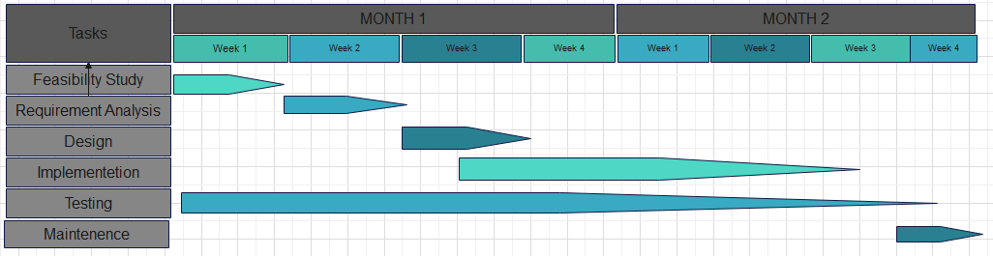

#### Figure 2: Project Gantt chart. Source: Edrawmax

### 3.6.5 Use case Analysis

The Fake News Detection System's use case diagram depicts the interactions between the system and its actors, which include students, teachers, and the system administrator. Students can register, log in, and enter news articles to get predictions on whether they are fake or real. Teachers have similar capabilities. The system administrator is responsible for managing user accounts, updating the machine learning model with fresh data, and monitoring system performance. Use cases represent each actor's interactions with the system, highlighting the functionalities that may be accessed and performed.

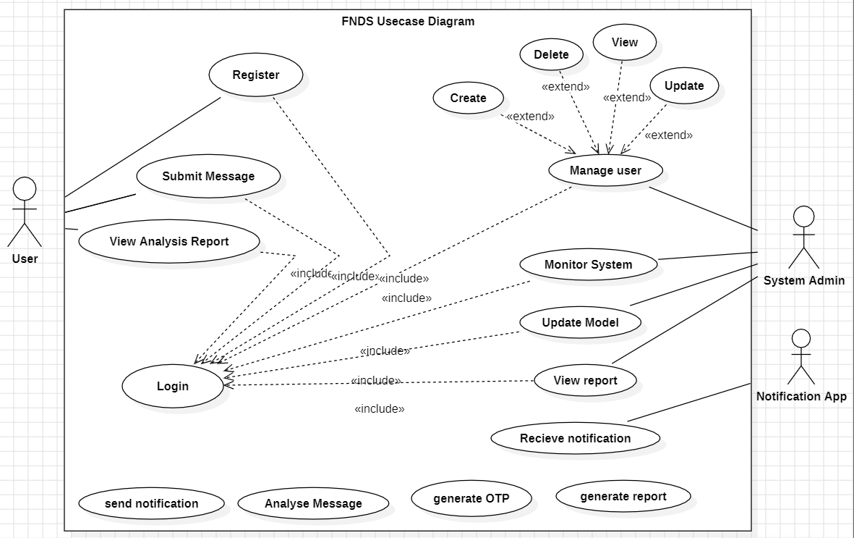

#### Figure 3: Usecase Diagram of FNDS. Source: StarUML

### 3.6.6 Sequence Diagram Sequence Diagram to check news

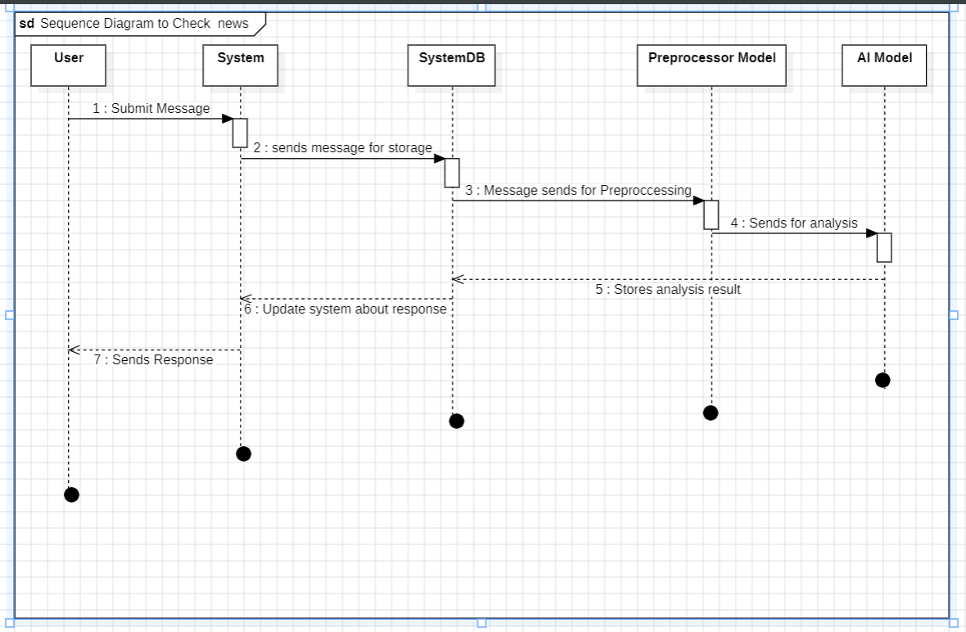

#### Figure 4: Sequence diagram to check news. Source: StarUML

**Sequence diagram to register user account**

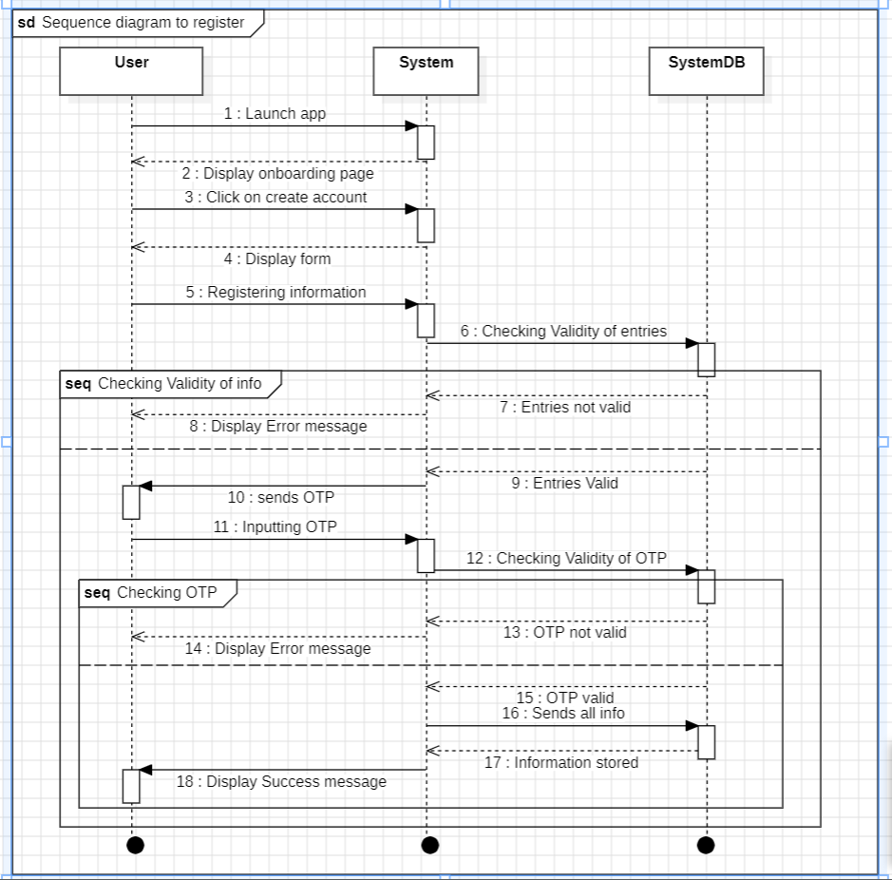

#### Figure 5: Sequence diagram to register user account. Source: StarUML

The sequence diagram above for user registration and message prediction in the Fake News Detection System outlines the step-by-step interaction between the user, the user interface, and the backend system. During registration, the user inputs their details, which are sent to the server for validation and storage in the database. Upon successful registration, the user receives a confirmation.

For message prediction, the user inputs a message, which is sent and stored in the database. The Preprocessor model then preprocesses the message, passes it to the machine learning model, and returns the prediction result to the user interface, displaying whether the message is fake or real.

### 3.6.7 Activity Diagram

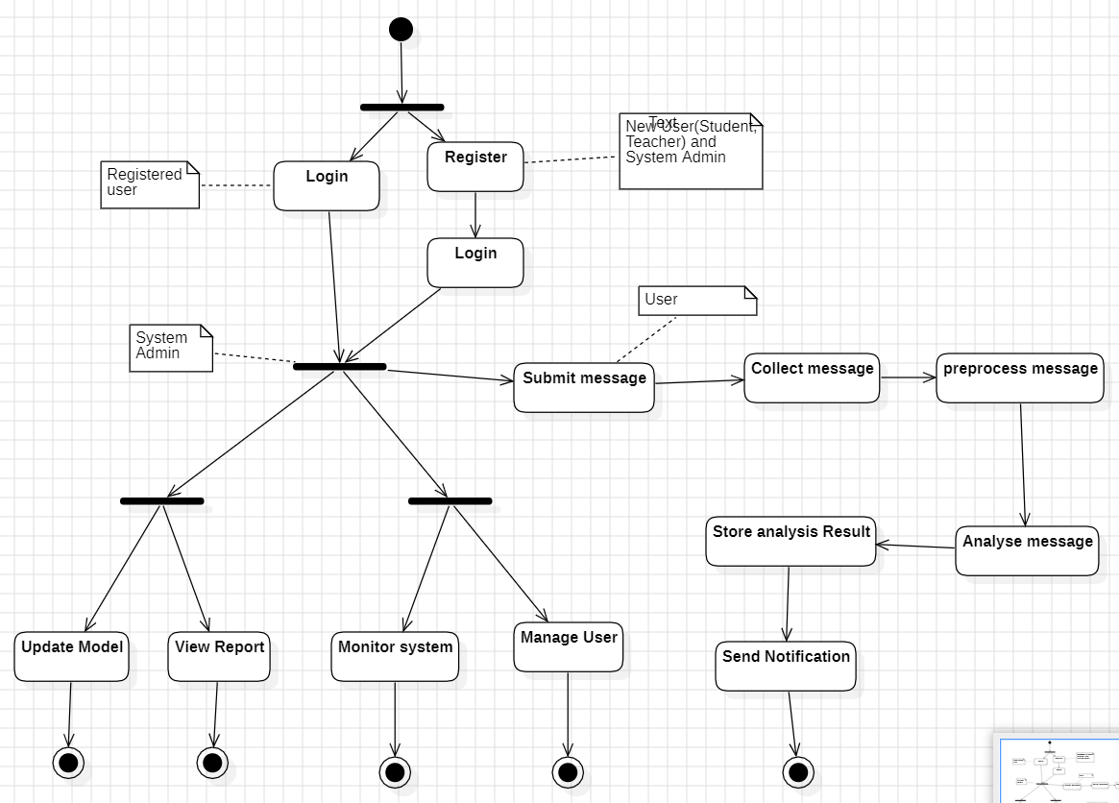

#### Figure 6: Activity Diagram of FNDS. Source: StarUML

The activity diagram above maps out the workflow of the system's processes. It starts with user registration, followed by login verification. Once logged in, users can input messages for prediction. The system preprocesses the input, runs the prediction through the machine learning model, and returns the result. The process ends with displaying the prediction to the user, highlighting the sequence of activities from start to finish. For the admin part, the diagram includes additional activities such as managing user accounts, updating the machine learning model with new data, and monitoring system performance, ensuring the system operates smoothly and efficiently.

### 3.6.8 Class Diagram

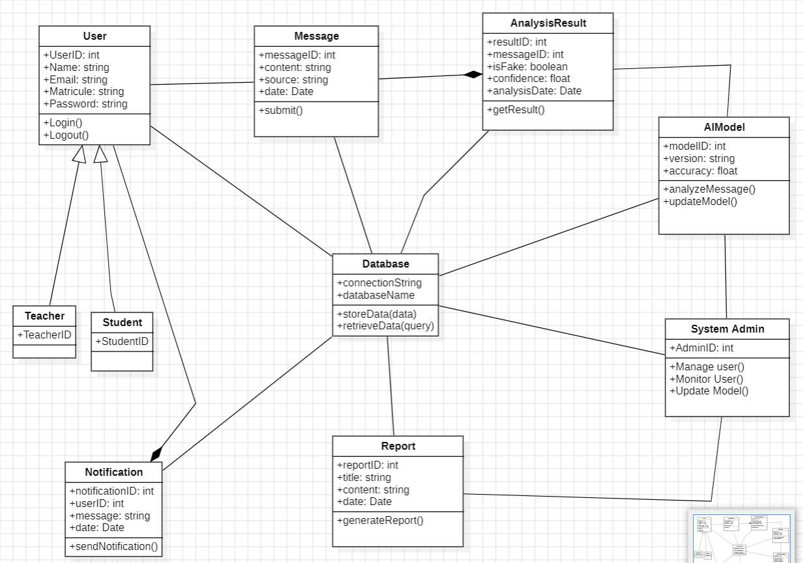

#### Figure 7: class diagram for FNDS. Source: StarUML

The class diagram for the Fake News Detection System represents the system's structure by detailing its classes and the relationships between them. Key classes include User, Student, Teacher, and Admin, each with attributes and methods for registration, login, and profile management. The Message class handles input messages with attributes for content and timestamps, and methods for preprocessing and prediction. The AIModel class manages the machine learning algorithms and prediction methods. The Database class ensures secure data storage and retrieval. Relationships between classes, such as inheritance between User and its subclasses, and associations between User and Message, are clearly depicted to show interactions and dependencies within the system.

### 3.6.9 Entity Relational Diagram

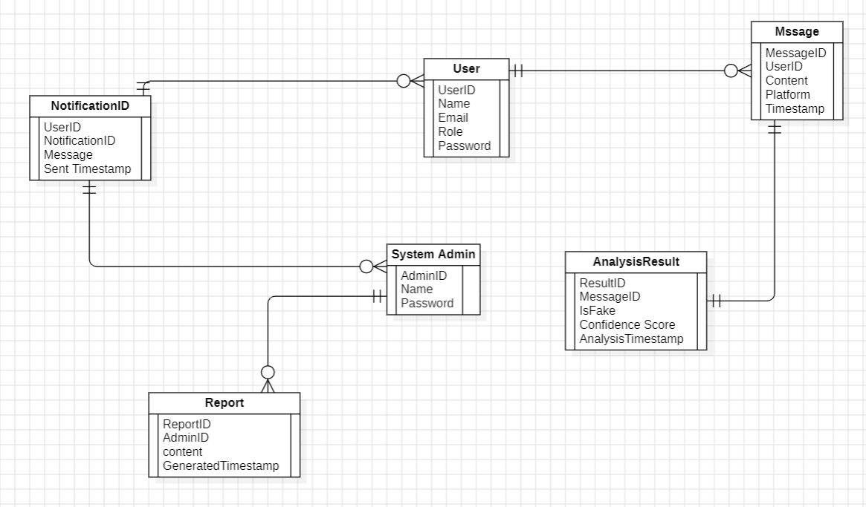

#### Figure 8: Entity Relation Diagram for FNDS. Source: StarUML

The Entity-Relationship (ER) diagram for the Fake News Detection System outlines the database structure by detailing the key entities and their relationships. Major entities include User, which has subclasses Student and Teacher, each with attributes such as UserID, Name, Email, and Password. The Message entity records details about the messages being analyzed, including MessageID, Content, and Timestamp. The admin entity manages system operations with attributes like AdminID, Name, and Role. Relationships between these entities are depicted with User having a one-to-many relationship with Message, indicating that each user can input multiple messages. Additionally, Admin has a management relationship with User, allowing administrators to manage user accounts and system configurations. This structure ensures efficient data management and clear interaction paths within the system.

### 3.6.10 System Designs

#### Figure 9: System User interface designs. Source: Figma

# CHAPTER FOUR

# IMPLEMENTATION, RESULTS AND TESTING

## 4.1. Introduction

This chapter delves into the practical implementation of the fake News Detection System (FNDS), which seeks to create a reliable and effective tool for identifying and categorizing news as true or fake. We begin by outlining the system's implementation, including the software and tools utilized for development, and then provide a step-by-step tutorial for implementing the Support Vector Machines (SVM) model. The dataset preparation procedure is described, including data collection, classification, and preprocessing to guarantee that it is clean and ready for model training. This chapter also discusses the methods for partitioning the dataset into training and testing sets, as well as the SVM model's training process and the testing phase to evaluate its performance.

The results section presents the outcomes from the testing phase, utilizing evaluation metrics such as accuracy, precision, recall, and F1-score to assess the system's effectiveness. A discussion follows, analyzing the results, identifying challenges faced during implementation, and the solutions adopted. Additionally, this chapter provides recommendations for further improvements and optimizations to enhance the system's accuracy and reliability. Through a systematic approach, this chapter demonstrates how the combination of machine learning techniques and effective data preprocessing can lead to the development of a robust fake news detection system.

## 4.2. Implementation

The implementation of the Fake News Detection System (FNDS) focused on creating a robust solution for classifying news articles as either fake or true. The process involved developing key components such as data preprocessing, model training, and a user-friendly interface. A Support Vector Machine (SVM) model was trained using labeled datasets to ensure accurate predictions. The system's code was thoroughly tested to guarantee functionality and reliability. Additionally, data handling processes were optimized for efficiency, and extensive validation was conducted to confirm the system's performance. The end result is a comprehensive and effective fake news detection tool.

### 4.2.1 Implementation of the AI Model Module: Data Collection, Preprocessing, and Detection

The AI model module is the heart of the Fake News Detection System (FNDS), encompassing the essential processes of data collection, preprocessing, and detection. It ensures that the system can accurately classify news articles by transforming raw data into a format suitable for machine learning algorithms and using a Support Vector Machine (SVM) model for prediction.

**Data Collection:** The initial phase in the AI model module is data collection. This entails compiling a thorough dataset of news articles labelled as "fake" or "true". These datasets were gathered from credible sources. For this project, two datasets are used: one with fake news and one with real news.

**Code implementation**

* **Importing Essential Libraries**

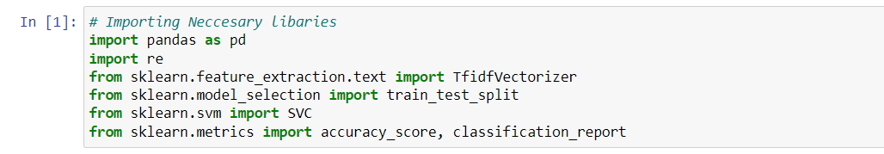

#### Figure 10: Code (import libraires). Source: Jupiter Notebook

The code imports necessary libraries for the project. It imports the pandas library as pd, the TfidfVectorizer class from the sklearn.feature_extraction.text module, and the train_test_split function, accuracy_score, and classification_report from various sklearn modules..

* **Loading the dataset**

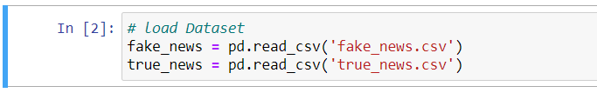

#### Figure 11: Code (loading dataset). Source: Jupiter Notebook

This code reads data from two CSV files, fake_news.csv and true_news.csv, into pandas DataFrames called fake_news and true_news, respectively.

* **Labelling and combining the dataset**

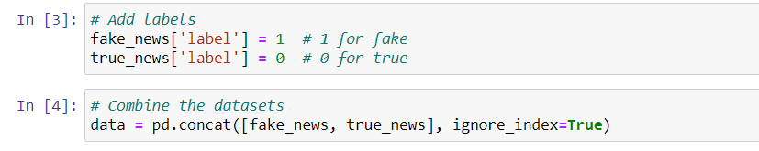

#### Figure 12: Code (label and combine the dataset). Source: Jupiter Notebook

This code assigns a label of 1 to fake news and 0 to true news, then it combines the two datasets into a single DataFrame named data, with the index reset.

**Data Preprocessing:** data preprocessing is a crucial step in preparing the collected data for the machine learning model. It involves cleaning the data, handling missing values, and transforming text data into numerical representations that the model can understand. The main steps include tokenization, removing stop words, stemming or lemmatization, and vectorization.

**Code Implementation:**

* **Adding Processing Function and Applying preprocessing**

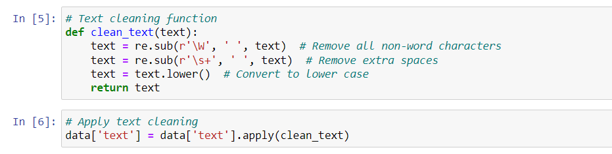

#### Figure 13: Code (adding processing functions and applying processing). Source: Jupiter Notebook

The code defines a function called clean_text() that performs text cleaning operations on the input text. The function first removes all non-word characters using the re.sub() function, then it removes any extra spaces in the text, and finally, it converts the text to lowercase using the lower() method. The function then returns the cleaned text. The second part of the code applies the clean_text() function to the 'text' column of the 'data' DataFrame, updating the 'text' column with the cleaned text. This preprocesses the text data, which is likely an important step before further analysis or model training.

* 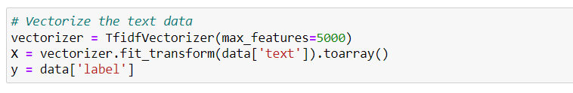**Vectorize the text data to TF-IDF feature vectors**

#### Figure 14: Code (Vectorize text data to TF-IDF). Source: Jupiter Notebook

The code vectorizes the text data using a TF-IDF (Term Frequency-Inverse Document Frequency) vectorizer with a maximum feature count of 5000. The generated feature vectors are stored in the variable 'X', and the 'label' column is assigned to the variable 'Y'.

* **Split the dataset to train and test data**

#### Figure 15: Code (Split dataset). Source: Jupiter Notebook

The code splits the data into training and testing sets using the train_test_split() function from the sklearn library. It takes the feature matrix X and the target variable y as inputs, and splits them into X_train, X_test, y_train, and y_test variables. The split is done with a test size of 0.2 (20% testing, 80% training) and a random state of 42.

**Detection:** The detection phase involves training the SVM model on the preprocessed data and using this trained model to classify news articles. The SVM algorithm is chosen for its effectiveness in text classification tasks. The model is trained, evaluated, and tested to ensure its accuracy and reliability in detecting fake news.

* **Training the SVM model**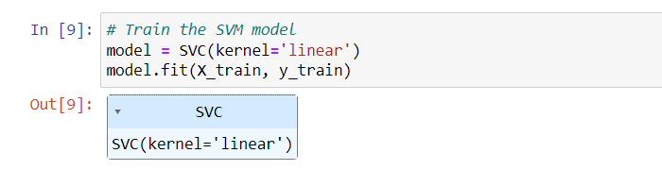

#### Figure 16: Code (Train the SVM model). Source: Jupiter Notebook

The code creates an SVC model with a linear kernel and trains it on the X_train and y_train data. The model is stored in the variable 'model'. This trains the SVM model to learn the patterns in the training data.

* **Predictions and Evaluation**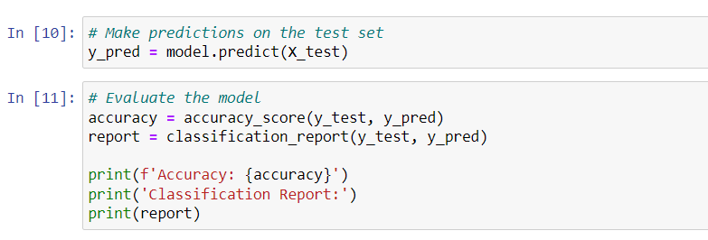

#### Figure 17: Code (predict and evaluates). Source: Jupiter Notebook

The code uses the trained SVM model to make predictions on the test data, which are then stored in the y_pred variable. It then evaluates the model's performance on the test data by computing the accuracy score and storing it in the accuracy variable. The code also generates a detailed classification report, which provides information about the model's precision, recall, F1-score, and support for each class. This report is stored in the report variable.  
Finally, the code prints the accuracy score and the classification report, allowing the user to assess the overall performance of the trained SVM model.

**User Input Prediction:** The user input prediction module allows users to directly enter news text for evaluation. This module utilizes the trained SVM model to predict whether the provided news text is true or fake based on the preprocessed and vectorized input. The prediction result is subsequently returned to the user, providing an immediate assessment of the news text's legitimacy.

* **Collect and Clean User Input**

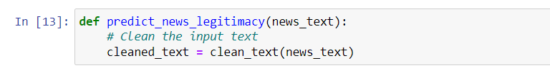

#### Figure 18: Code (Collect and clean user input). Source: Jupiter Notebook

This code snippet defines the function predict_news_legitimacy, which accepts news_text as input. The function cleans the input text with another function named clean_text and stores the result in the variable cleaned_text. This makes the text ready for further processing or analysis.

* **Vectorize and predict User Input**

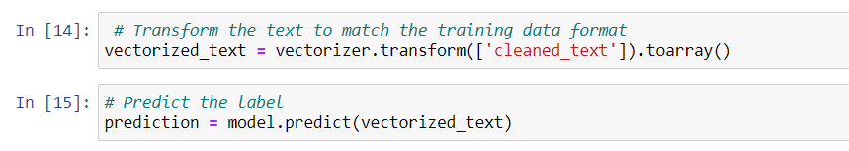

#### Figure 19: Code (Vectorize and Predict user input). Source: Jupiter Notebook

This code snippet transforms the cleaned text into a format compatible with the training data using the vectorizer and converts it to an array. It then uses a machine learning model to predict the label (fake or real) of the transformed text. The predicted label is stored in the prediction variable.

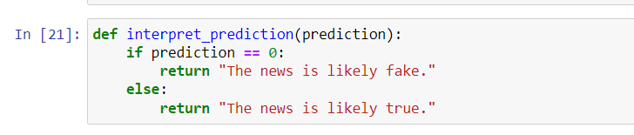

#### Figure 20: Code (interpreting predictions). Source: Jupiter Notebook

The code defines a function called interpret_prediction, which accepts a prediction value as input. If the forecast is 0, it returns "The news is most likely fake." Otherwise, it returns "The news is most likely true." This function interprets the model's prediction and returns a readable result indicating the validity of the news.

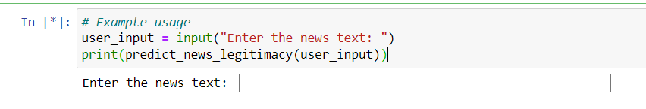

#### Figure 21: Code (testing user input prediction). Source: Jupiter Notebook

The code prompts the user to type in news text. It then invokes the function predict_news_legitimacy, passing the user's data to it. The function uses the trained SVM model to examine the input and predict the authenticity of the news text. The result of the prediction is then printed.

### 4.2.2 Implementation of user interface

The user interface was implemented with HTML to define the structure of the web page. CSS was used to style the elements, ensuring a visually appealing layout. JavaScript was integrated to add interactivity and dynamic behavior, enhancing the user experience. This combination creates a responsive and functional interface.

* 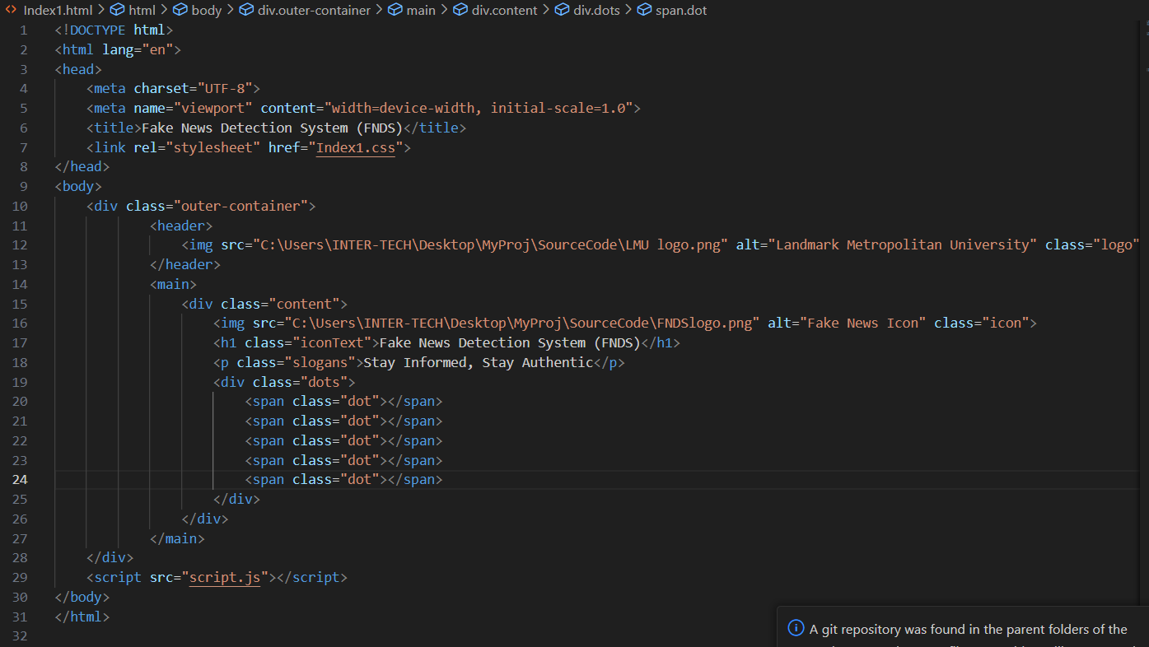**HTML of the App onboarding page**

#### Figure 22: HTML of the App onboarding page. Source: VSCode

* 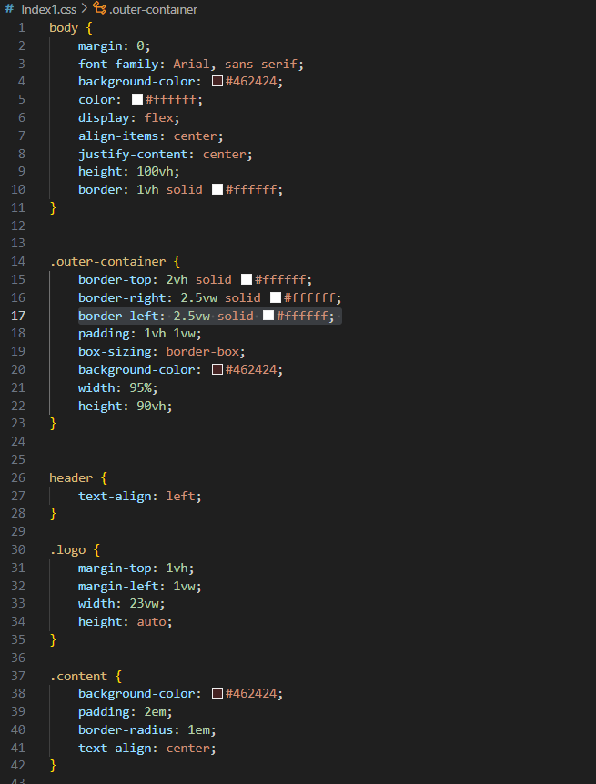**CSS of the App onboarding page**

#### Figure 23: CSS of the onboarding page. Source: VSCode

The user interface is made up of multiple pages (all the codes snippet are not display in this document) that are seamlessly linked together, resulting in a coherent navigation experience. Each page is cautiously styled to maintain visual consistency and appeal, with CSS used to achieve an optimal layout. The usage of JavaScript increases interactivity, resulting in a more dynamic and interesting user experience. Overall, the well-crafted UI provides users with an easy and delightful journey through the application.

## 4.3 Result of the Implementation

### 4.3.1 Onboarding UI on the browser

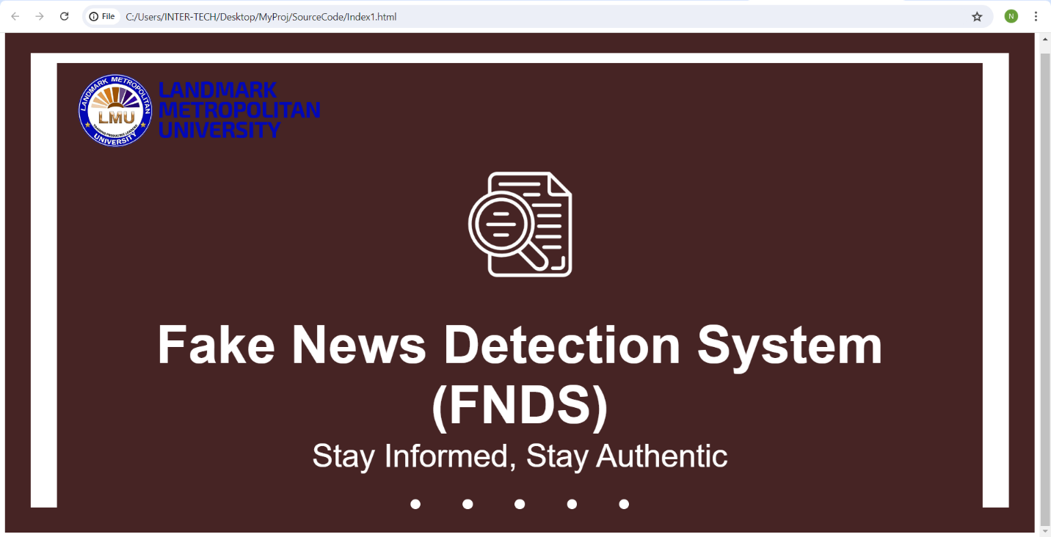

#### Figure 24: Onboarding UI on the browser. Source: Chrome browser

### 4.3.2 First Login UI on the browser

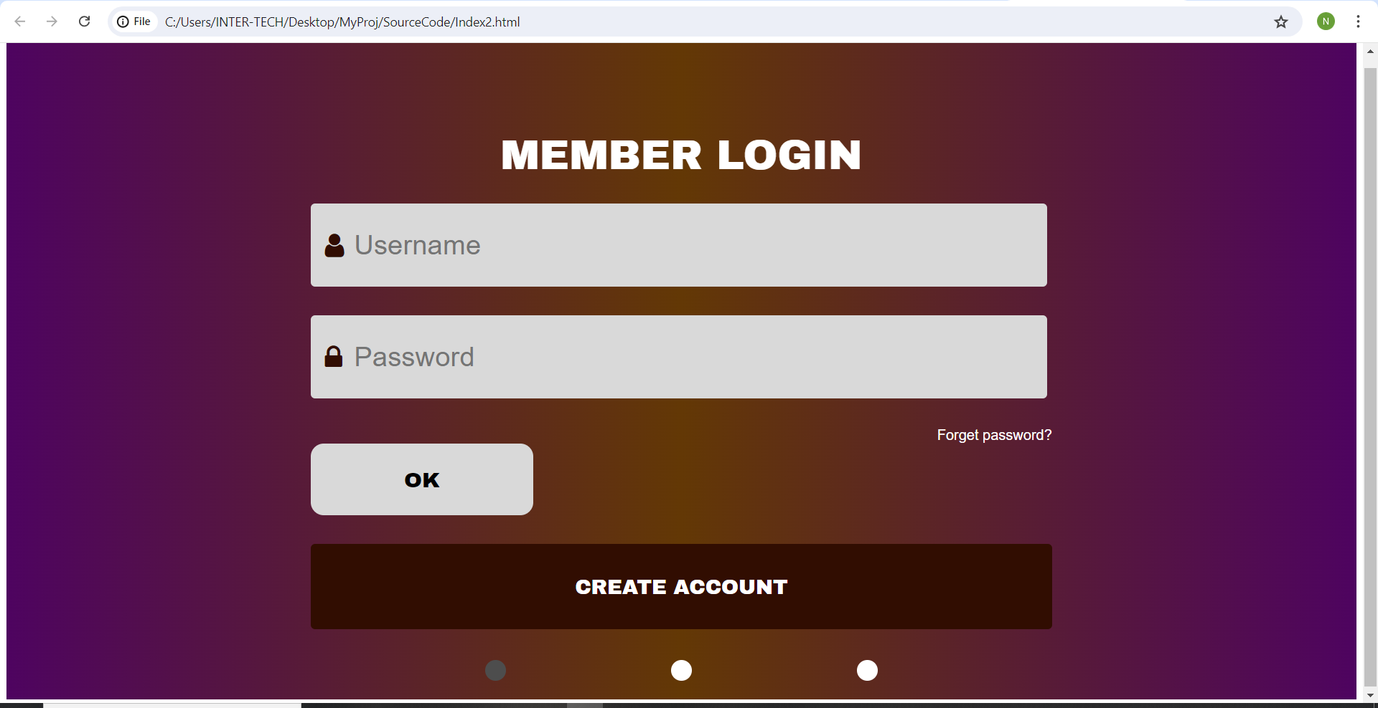

#### Figure 25: First Login UI on the browser. Source: Chrome browser

### 4.3.3 Second Login UI on the browser

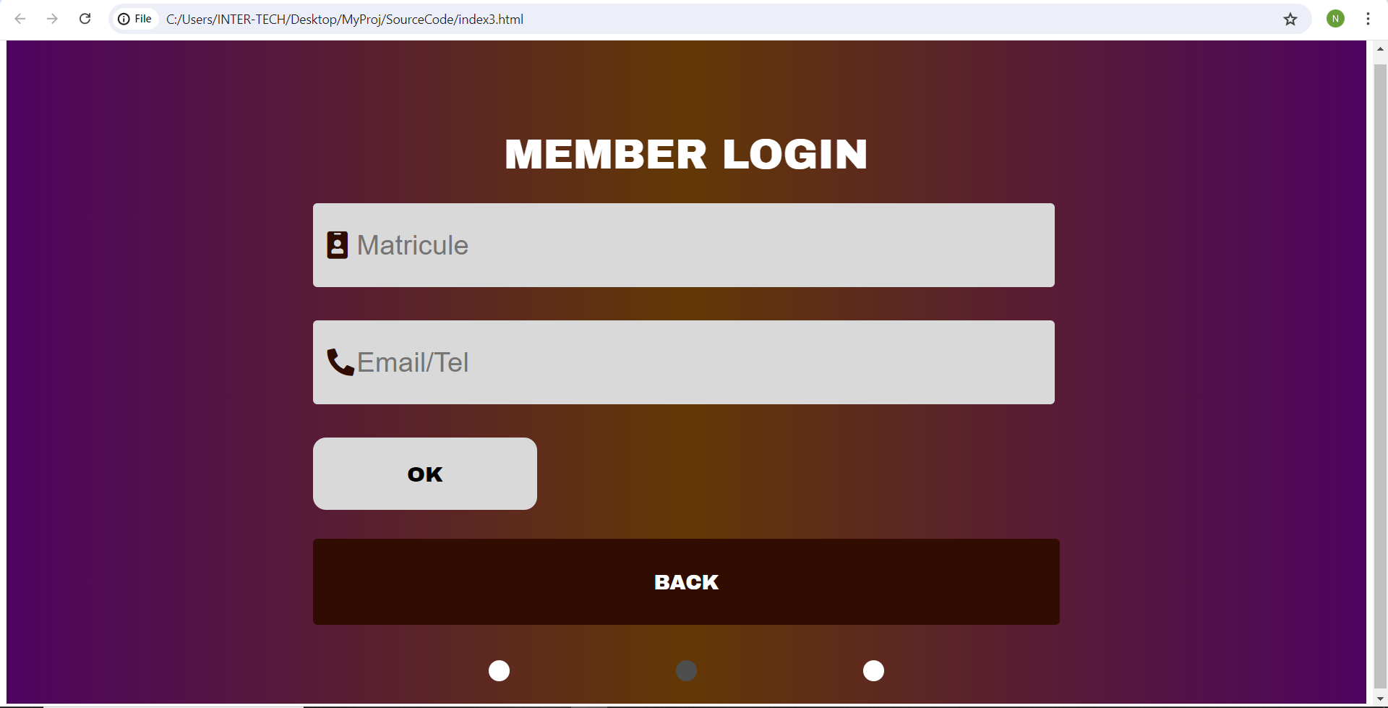

#### Figure 26: Second Login UI on the browser. Source: Chrome browser

### 4.3.2 OTP Verification UI on the browser

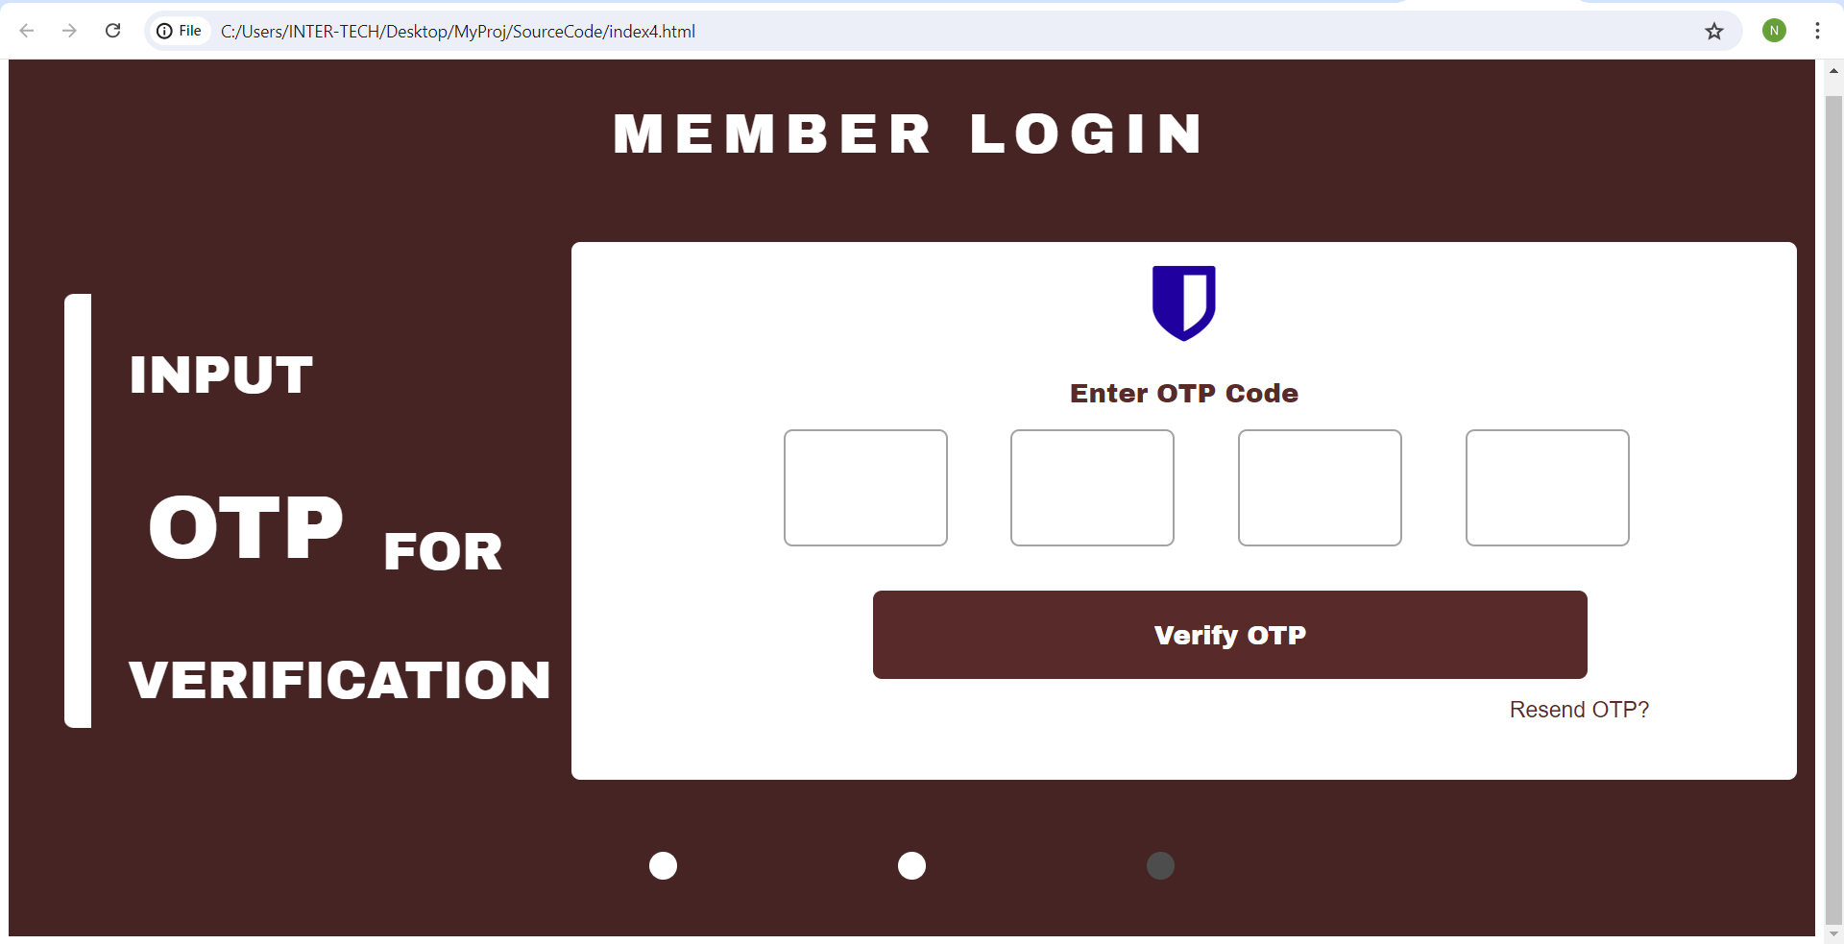

#### Figure 27: OTP Verification UI on the browser. Source: Chrome browser

## 4.4. System Testing Strategies

### 4.4.1 Unit Testing

* **Model Evaluation and Testing using Classification Metrics:** I employed comprehensive model evaluation as a primary testing technique, using classification metrics to assess the AI model's performance. The results show an overall accuracy of 99.37%, indicating the percentage of correctly classified instances out of the total instances. The classification report provides a detailed breakdown with high precision, recall, and F1-scores of 0.99 for both classes (0 and 1), reflecting the model's ability to correctly identify true positives and minimize false positives and negatives. The support values indicate the number of actual occurrences for each class in the dataset. This thorough evaluation ensures that the model maintains high performance across all relevant metrics.

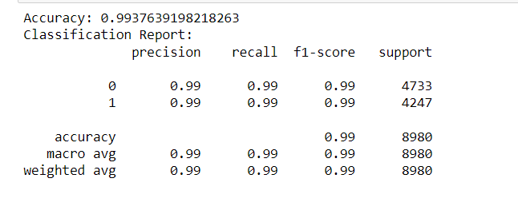

#### Figure 28: Result of the model evaluation. Source: Jupiter Notebook

* **Continuous Browser Testing:** I implemented continuous browser testing as a key strategy to ensure the user interface (UI) is robust and user-friendly. By repeatedly running the UI code in various web browsers, I was able to assess the interface's responsiveness, functionality, and overall user experience. This approach helped identify and rectify any inconsistencies or issues across different platforms and devices, ensuring a seamless and visually appealing experience for all users.

### 4.4.2 System Testing

* **Test Case Development for Functionality**: I developed specific test cases to thoroughly evaluate the functionality of the application. These test cases covered a range of scenarios to ensure that features performed as expected. By systematically executing these tests, I was able to detect and fix bugs and issues, thus enhancing the reliability and performance of the application. This methodical approach ensured comprehensive coverage and validation of the application's functional aspects.

### 4.4.3 Test cases for Functionality

* **Login Functionality:**

Objective: Verify that users can log in with valid credentials.

Steps: Enter a valid username and password, then click "Login."

Expected Result: The user should be successfully logged in and redirected to the homepage.

* **Sign-up Functionality:**

Objective: Ensure that new users can create an account.

Steps: Fill in the registration form with a valid username, email, and password, then click "Sign Up."

Expected Result: The user should receive a confirmation message and be able to log in with the new credentials.

* **News Submission:**

Objective: Verify that users can submit news articles.

Steps: Navigate to the submission page, enter a news article, and click "Submit."

Expected Result: The article should be saved and appear in the news feed.

* **Fake News Detection:**

Objective: Test the fake news detection feature.

Steps: Submit a known fake news article and check the detection result.

Expected Result: The system should correctly identify the article as likely fake.

* **Profile Update:**

Objective: Ensure users can update their profile information.

Steps: Navigate to the profile page, change the necessary details, and save.

Expected Result: The profile should update with the new information.

* **Search Functionality:**

Objective: Test the search feature to find news articles.

Steps: Enter a keyword in the search bar and hit "Search."

Expected Result: The system should display relevant articles that match the keyword.

* **Logout Functionality:**

Objective: Verify that users can log out successfully.

Steps: Click on the "Logout" button.

Expected Result: The user should be logged out and redirected to the login page.

# CHAPTER FIVE

# CONCLUSION AND RECOMMENDATIONS

## 5.1 Discussion

The Fake News Detection System project uses machine learning approaches to address the widespread problem of disinformation in schools. During a two-month development period, the system will be developed to evaluate text-based content from popular social media platforms utilized by the school, including Facebook, WhatsApp, YouTube, Instagram, and Twitter. The project has several stages, including data collecting, model training, system design, and user interface development. The methodology adopted assures a systematic approach to creating a strong and dependable system capable of discriminating between authentic and fraudulent news. The initiative also stresses user-friendliness, allowing students and teachers to engage with the system and receive accurate predictions.

## 5.2 Conclusion

The Fake News Detection System is a key step toward improving information integrity in the school community. By combining machine learning techniques with a user-friendly interface, the system provides a realistic answer to the problem of disinformation. The project's successful completion will result in a tool for verifying the veracity of news, creating a more informed and critical-thinking student population. This project also emphasizes the need of using technological solutions to address current difficulties in education.

## 5.3 Recommendations

* User Training: Provide extensive training to students, teachers, and administrators to ensure that they can effectively use the system.
* Continuous Improvement: To maintain high prediction accuracy, the machine learning model should be updated on a regular basis with fresh data.
* Integration: Consider linking the technology with the school's existing communication platforms to ensure smooth access.
* Feedback Mechanism: Implement a feedback mechanism to allow users to report inaccuracies and suggest improvements.
* Privacy Measures: Ensure that strong data privacy safeguards are in place to secure user information and preserve confidence.

## 5.4 Perspective of Further Studies

* Multilingual Support: Future research could look into the development of multilingual capabilities to make the system more accessible to non-English speakers.
* Enhanced Data Sources: Consider including other data sources, such as academic databases and news websites, to improve the model's comprehensiveness.
* Advanced Algorithms: Investigate the use of increasingly sophisticated machine learning and natural language processing approaches to improve detection accuracy.
* User Behavior Analysis: Investigate the system's impact on user behavior and information consumption patterns within the school.
* Scalability: Look for ways to scale the system for usage in other schools or educational institutions, making sure it can manage larger user bases and various data sets.

# *REFERENCING STYLE*

Alpaydin, E. (2016). Machine Learning: The New AI. MIT Press, Cambridge, MA.

*Analytics Vidhya. (n.d.). Understanding Support Vector Machine(SVM) Algorithm from Examples (along with code). Retrieved from* [*https://www.analyticsvidhya.com/blog/2017/09/understaing-support-vector-machine-example-code/*](https://www.analyticsvidhya.com/blog/2017/09/understaing-support-vector-machine-example-code/)

Del Vicario, M., Bessi, A., Zollo, F., Petroni, F., Scala, A., Caldarelli, G., ... & Quattrociocchi, W. (2016). ‘The spreading of misinformation online”. *Proceedings of the National Academy of Sciences, 113(3), 554-559.*

Domingos, Pedro (2015). The Master Algorithm: How the Quest for the Ultimate Learning Machine Will Remake Our World. Basic Books, New York.

Fawcett, Tom, and Foster Provost (2013). Data Science for Business: What You Need to Know about Data Mining and Data-Analytic Thinking. O'Reilly Media, Sebastopol, CA.

*Google AI Blog. (n.d.). Advances in Natural Language Processing. Retrieved from* [*https://ai.googleblog.com/search/label/Natural%20Language%20Processing*](https://ai.googleblog.com/search/label/Natural%20Language%20Processing)

Kula, S., & Sun, L. (2020). “Fake news detection with SVM and deep learning”. *2020 3rd International Conference on Information and Computer Technologies (ICICT), 189-193.*

Marcus, Gary (2015). The Future of the Brain: Essays by the World's Leading Neuroscientists. Princeton University Press, Princeton, NJ.

*Medium - Towards Data Science. (n.d.). Detecting Fake News with Python and Machine Learning. Retrieved from* [*https://towardsdatascience.com/detecting-fake-news-with-python-machine-learning-11d4f4b8b7f9*](https://towardsdatascience.com/detecting-fake-news-with-python-machine-learning-11d4f4b8b7f9)

*MIT Technology Review. (n.d.). How AI and Machine Learning are Used to Detect Fake News. Retrieved from* [*https://www.technologyreview.com/2020/07/01/1004533/how-ai-and-machine-learning-are-used-to-detect-fake-news/*](https://www.technologyreview.com/2020/07/01/1004533/how-ai-and-machine-learning-are-used-to-detect-fake-news/)

*OpenAI Blog. (n.d.). Combating Misinformation with AI. Retrieved from* [*https://openai.com/blog/misinformation/*](https://openai.com/blog/misinformation/)

Pérez-Rosas, V., Kleinberg, B., Lefevre, A., & Mihalcea, R. (2018). « Automatic detection of fake news”. *Proceedings of the 27th International Conference on Computational Linguistics, 3391-3401.*

Russell, Stuart, and Peter Norvig (2020). Artificial Intelligence: A Modern Approach. Pearson, Upper Saddle River, NJ.

*Scikit-learn. (n.d.). Support Vector Machines. Retrieved from* [*https://scikit-learn.org/stable/modules/svm.html*](https://scikit-learn.org/stable/modules/svm.html)

*Towards Data Science. (n.d.). A Comprehensive Guide to Support Vector Machine. Retrieved from* [*https://towardsdatascience.com/a-comprehensive-guide-to-support-vector-machine-6223b396f837*](https://towardsdatascience.com/a-comprehensive-guide-to-support-vector-machine-6223b396f837)